Testing

B Kendrick, A Syed

Contents

Introduction 3

Test Types 3

Test Environment 3

Test Data 4

Sample User Project 4

Class Diagram for Sample Project 4

Variable Types 4

Sample Methods 4

Constructors 5

Utilities 5

String Helper 5

Object Bench Utility 5

Test Plan 5

Object Bench 5

Class Diagram 6

Inspector 7

Dialogs 8

Constructor Dialog 8

Method Call Dialog 9

New Class Dialog 9

New Package Dialog 10

Utilities 10

Java Model Helper 10

String Helper 10

Object Bench Utility 10

Test Results 11

Object Bench 11

Class Diagram 11

Inspector 12

Dialogs 13

Constructor Dialog 13

Method Call Dialog 13

New Class Dialog 13

New Package Dialog 14

Utilities 14

String Helper 14

Object Bench Utility 14

Unit Testing 15

Unit Test Results 16

Beta Testing 17

Client & User Feedback 17

Observations During Testing 20

Educational Testing 20

Week 1 20

Week 2 21

Week 3 21

Week 4 21

Week 5 21

Week 6 21

Week 7 22

Week 8 22

Week 9 22

week 10 22

week 11 22

Week 12 22

Week 13 23

Educational testing Conclusion 23

Action Plan 23

Conclusions 23

Appendix A: Test Screenshots 24

Object Bench 24

Test 1 24

Test 2 24

Test 3 25

Test 4 26

Test 5 27

Test 7 27

Class Diagram 28

Test 1 28

Test 2 29

Test 3 29

Test 4 30

Test 5 31

Test 6 32

Test 7 33

Test 8 34

Test 12 35

Test 14 36

Test 15 37

Inspector 37

Test 1 37

Test 2 38

Test 3 38

Test 4 39

Test 5 40

Test 6 41

Constructor Dialog 42

Test 1 42

Test 2 42

Test 3 43

Test 4 43

Test 5 44

Test 6 45

Method Call Dialog 45

Test 1 45

Test 2 46

Test 3 46

Test 4 47

New Class Dialog 49

Test 1 49

Test 2 49

Test 3 54

New Package Dialog 54

Test 1 54

Test 2 55

Test 3 55

Educational Testing 57

# Introduction

As outlined in the design document we will use a variety of techniques to fully test the plugin to ensure that it meets the requirements of our client and users. The testing will comprise of alpha and beta testing using a combination of white and black-box testing.

# Test Types

The tests undertaken will fall into one of the following categories:

* **Validation** – Tests that ensure no erroneous or dangerous data can be entered into the system.
* **Functionality** – Tests that will evaluate a specific function or the functionality of a specified component.
* **Output** – These will test the output result from a component or function.
* **Stress** - Tests that will determine how well the system handles large demanding data.

# Test Environment

To test the plugin we will be using a clean install of Eclipse Luna with no additional plugins, this ensures that there are no conflicting issues with other tools and external utilities. Alpha testing will be performed on the same PCs the software was developed in but beta testing will be conducted in a computer lab within the University of Huddersfield. A user project will be created with a range of classes, each class will have different constructors and methods along with a variety of variables to test different types and how the user code is handled.

Each test will be run a minimum of one time with repeat tests only being conducted if bugs are fixed before the project reaches a conclusion.

# Test Data

## Sample User Project

### Class Diagram for Sample Project

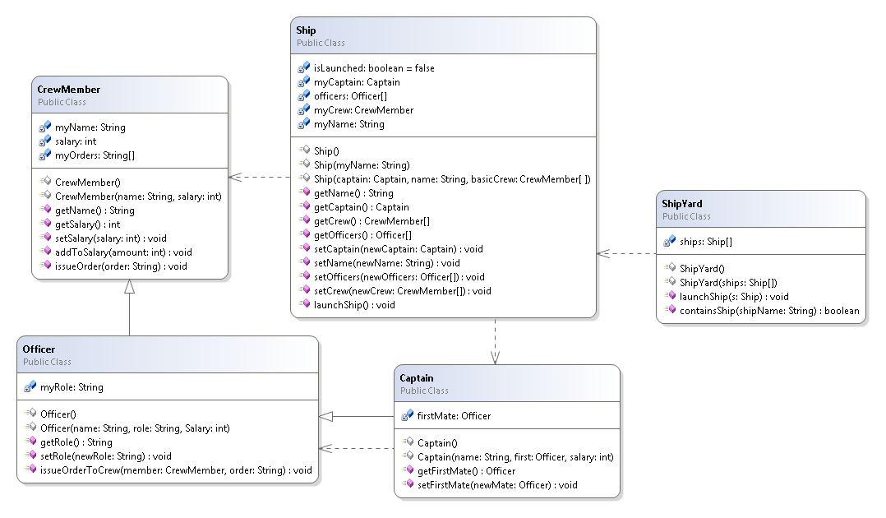

Figure - Sample project class diagram

### Variable Types

We will use a variety of different variable types whilst testing the plugin:

* **Numeric**
* **String**
* **User Class (Name tomorrow)**
* **Array (String, Numeric, User Class)**
* **Boolean**

### Sample Methods

A few of the methods contained in the sample project will be used to determine that the system is working correctly. We will measure whether the return value is of the correct type and the result is correct. We will use some of the methods to both set and get variables and perform actions to ensure that the effects on other instances remain consistent with the objects on the object bench.

### Constructors

Constructors will be created in order to test and ensure a variety of class constructors are supported and that instances can be created onto the object bench with a variety of different parameters.

## Utilities

### String Helper

Table 1 – String Data

|  |  |  |
| --- | --- | --- |
| Type | Value | Notes |
| String | “TestClass.java” |  |
| String | “QString |  |
| String | “I” |  |
| String | “[I” |  |
| String | “com.test” |  |
| String | “TestClass” |  |

### Object Bench Utility

Table 2- Object Bench Utility Data

|  |  |  |
| --- | --- | --- |
| Type | Value | Notes |
| String | “I” |  |
| String | “asdfawe” |  |
| Class | Int |  |
| Class | String |  |
| Class | boolean |  |

# Test Plan

## Object Bench

Table 3 – Object Bench Test Plan

|  |  |  |  |  |
| --- | --- | --- | --- | --- |
|  | Type | Data | Description | Expected Result |
| 1 | Functionality | Instance(CrewMember) | To test if an instance can be removed from the bench. | The instance will be removed from the bench. |
| 2 | Functionality | Instance(CrewMember)x3  Instance(Ship)  Instance(Captain) | To test if the object bench can be cleared with the clear bench function. | The bench will be cleared and instances destroyed. |
| 3 | Functionality  /Output | Instance(Ship)  Method(launchShip) | To test if a method can be called, in this case the launchShip() method which simply switches a boolean flag from false to true. | The system should return a value of true displayed in a dialog informing the user of the result of the methods return call. |
| 4 | Output | Instance(CrewMember)  Method(addToWage) | To test if a method can be called and output results based on the input parameters. The method here takes a parameter of integer, this number is then added to the salary field, and the result will be the salary plus the integer. | The system will display the added value in a dialog along with the return type. |
| 5 | Functionality | Instance(Ship) | To test when an instance is “selected” via a single click its fields are shown in the inspector view. | The fields of the selected instance will be displayed in the inspector view. |
| 6 | Stress | Various Instances (x100) | A test to see if the object bench can handle 100 instances. | The object bench should handle the instances but may begin to cause minor issues with performance. |
| 7 | Functionality | Instance(Ship) | Testing to ensure that all the methods are available in the right-click context menu ready to be called. The methods that should be displayed can be found in the class diagram of the sample project. | There will be a list of methods that belong to the selected instance (Ship). |

## Class Diagram

Table 4 – Class Diagram Tests

|  |  |  |  |  |
| --- | --- | --- | --- | --- |
|  | Type | Data | Description | Expected Result |
| 1 | Functionality | New Class(Name: “TestClass” Template: Standard) | A simple test to ensure a new class can be added to a selected package. | A new class will be created and displayed in the class diagram view. |
| 2 | Functionality | New Package(Name: “TestPackage”) | A test to ensure a new package can be added to the system. | A new package will be added to the project and displayed in the class diagram view. |
| 3 | Functionality | Class(TestClass) | To test that a class can be deleted. | The class will be deleted and the rendered object removed. |
| 4 | Functionality | Package(TestPackage) | To test that a package can be deleted. | The package will be deleted and removed from view. |
| 5 | Functionality | Class(Ship)  Constructor( | To test that an instance can be added to the object bench using a zero parameter constructor. | An instance of the “Ship” class will be added to the object bench. |
| 6 | Functionality | Class(Ship) Constructor(String “Orion”) | To test that an instance can be created with a parameter. The constructor selected will set the value of a ships name; we will be able to validate this by inspecting the created instance. | The instance will be created and the name selected will be displayed in the relevant field on the inspector. |
| 7 | Validation | NewPackage(“package.test”) | To test whether a package name can contain the package word, an invalid parameter. | The system should reject the entry with an error message. |
| 8 | Validation | NewClass(“Test Class”) | To test whether a class can have a space in its name. | The system should reject the entry with an error message. |
| 9 | Output | Class(Officer, CrewMember) | To test if the inheritance of Officer is shown on the class diagram view. | The inheritance will be represented by the class diagram view. |
| 10 | Output | Class(Ship,CrewMember) | To test if the dependence is drawn between two classes when one class depends on the other. | The class diagram should represent the dependency between the two classes with a dotted line. |
| 11 | Output | Sample Project | To test if the class diagram view accurately draws the relationships between the classes in a project. | The class diagram view should represent the project in a similar manner to the class diagram outlined in the test data. |
| 12 | Validation | NewClass(“TestClass”)  NewClass(“TestClass”) | To test if multiple classes of the same name can be added. | The system should overwrite the previous instance and allow the new version of the class to be loaded. |
| 13 | Stress | Sample Project + 20 new classes. | To test if the system can handle more than 10 classes at a time. | The system should handle it but the diagram may be difficult to read and understand. |
| 14 | Functionality | Class(Ship) | To test if a class can be opened in the code editor when double clicked or selected from the context menu from the view. | A code editor window will open for the selected class. |
| 15 | Functionality | Class(Ship) | To test if the correct constructors are present in the context menu associated with the class. These can be found in the class diagram for the sample project. | The constructors will be correct and selectable. |

## Inspector

Table 5 – Inspector Tests

|  |  |  |  |  |
| --- | --- | --- | --- | --- |
|  | Type | Data | Description | Expected Result |
| 1 | Functionality | Instance(CrewMember) | A simple test to ensure that a selected instance displays in the inspector. | The instance will be displayed in the inspector. |
| 2 | Validation | Instance(TestClass)  Fields(int,String,boolean) | A test to ensure that the correct controls are retrieved for each type. | The instance will be displayed in the inspector with a Spinner, Text Field and Check Box for entering values for the fields. |
| 3 | Validation/  Output | Instance(CrewMember)  Array(myOrders)  Size(3)  Values([1]”Test Order”  [2]”Sample Order”  [3]”Last Order”) | A test to ensure that an array can be re-sized and values entered into each item within the array. | The values within the array will be set as required and the resizing will work as intended. |
| 4 | Validation | Instance(Ship)  Field(myName)  Value(“Delta”) | A test to enter a name for the ship. | The name will be accepted and the stored. |
| 5 | Output | Instance(Ship)  Method(getName) | Testing to ensure that a newly entered value will be accessible from a method. | The name changed from ”Orion” to “Delta” will be displayed in a dialog when then method is called from the object bench. |
| 6 | Functionality | Instance(Ship)  Instance(Captain) x 3  SelectedInstance(Ship)  Field(myCaptain)  FieldValue(Captain2) | A test to see if an instance can be assigned to another instance as a field. | The instances will be displayed as options within the inspector for the required field. The field can then be set and a Captain selected. |

## Dialogs

### Constructor Dialog

Table 6 – Constructor Dialog Tests

|  |  |  |  |  |
| --- | --- | --- | --- | --- |
|  | Type | Data | Description | Expected Result |
| 1 | Functionality | Class(Ship)  Constructor(Captain, String)  Instance(Captain) x2 | A test to ensure that the correct controls are provided when creating a new instance through the constructor dialog. | There should be a text field and a drop down menu to select an instance for the construction of the instance. |
| 2 | Functionality | Class(Ship) | Test that a construction of an instance can be cancelled. | The window should close and no instance will be created. |
| 3 | Validation | Class(Officer)  Constructor(String, String, int) | To ensure string values cannot be entered into int spinners. | The value should be rejected. |
| 4 | Stress | NewClass(“TempNewClass”)  Constructor(String, String, int, int, int, int, int, int, int, int, int) | To test a long constructor. | The dialog should expand and accommodate all controls. |
| 5 | Validation/  Output/  Functionality | Class(Ship)  Constructor(Captain, String, CrewMembers) | To test if an instance can be used from the object bench, in this case the Captain field. | The field should be selectable from instances on the object bench. |
| 6 | Validation | Class(Ship)  Constructor(Captain, String, CrewMembers) | To test if a user defined field can be set to null. | The system should allow the user to set an instance value to null. |

### Method Call Dialog

Table 7 – Method Call Dialog Tests

|  |  |  |  |  |
| --- | --- | --- | --- | --- |
|  | Type | Data | Description | Expected Result |
| 1 | Functionality | Class, Instance(Ship)  Method(getName) | Test that a method is called correctly. | The ships name either “Orion” or “Delta” will be presented in a dialog. |
| 2 | Functionality | Class, Instance(CrewMember)  Method(addToSalary) | To test that parameters can be added to a method call and affect the result. | The method will accept the parameter and return a relevant value. |
| 3 | Validation | Class, Instance(Officer)  Instance(CrewMember) x2  Method(giveOrderToCrewMember)  Parameters(CrewMember, String)  Values(CrewMember1, “Test Order”) | To test that the correct controls are created for the parameters in the method. | In this instance the dialog should display controls for a CrewMember represented by a drop down menu and a text field to represent the String value. |
| 4 | Validation/  Output | Instance(Officer) x 3  Instance(Ship)  Method(setOfficers)  Parameters(Officer[])  Array(officers)  Size(3)  Values([1]Officer 1  [2]Officer 2  [3]Officer 3) | To test that arrays can be used as a parameter in methods. | The array will be fully editable and the values will be set as required. |

### New Class Dialog

Table 8 – New Class Dialog Tests

|  |  |  |  |  |
| --- | --- | --- | --- | --- |
|  | Type | Data | Description | Expected Result |
| 1 | Functionality | NewClass(“TestClass”)  Template(“Default”) | To test if a class can be created, this is the same process as creating a class from the class diagram so the result should be the same. | A new class will be created using the default template. |
| 2 | Validation/  Output | NewClass(“TestClass”)  Template(ALL) | To test if all templates work when requested. | A class can be created with each template type. |
| 3 | Output | NewClass(“TestClass”) | To test if a new class is named correctly and core syntax is correct. | The core syntax will be correct and both class and package names will be correct. |

### New Package Dialog

Table 9 – New Package Dialog Tests

|  |  |  |  |  |
| --- | --- | --- | --- | --- |
|  | Type | Data | Description | Expected Result |
| 1 | Functionality | NewPackage(“one”) | To test a package can be created. | The package will be created. |
| 2 | Functionality | NewPackage(“one.more.time”) | To test a multi-depth package can be created. | Multiple packages will be created providing the depth as required. |
| 3 | Validation | NewPackage(“package.test”) | To test whether a package name can contain the package word, an invalid parameter. | The system should reject the entry with an error message. |

## Utilities

### Java Model Helper

Throughout development of the project the java model has been tested by using print statements to ensure the correct results throughout. However due to the nature of the class it is very difficult to test independently as it relies on some aspects of the IDE to be working that we have no access to manipulate and set based on parameters we wish to define.

However it stands to reason that if the Java Model Helper were erroneous then the entire system would fail as this is the backbone upon which the majority of the plugin is built. The Java Model Helper allows for traversal of classes and packages throughout a user project, this allows the user to interact with their code. This can be verified as working if the majority of other functions throughout the plugin are working as intended.

### String Helper

Table 10 - String Helper Tests

|  |  |  |  |  |
| --- | --- | --- | --- | --- |
|  | Type | Data | Description | Expected Result |
| 1 | Functionality/  Validation | “TestClass.java” | Test that a string is stripped of its extension. | The resulting string will be “TestClass” |
| 2 | Functionality/  Validation/  Output | “QString” “I” “[I” | This test will enable us to test the “fixType” method. Fixing type allows for correct class loading. | The string helper will output “String” “int” “int[]”. |
| 3 | Output | “com.test” “TestClass” | Testing the method to get qualified name. | The string helper will return “com.test.TestClass” |

### Object Bench Utility

Table 11 – Object Bench Utility Tests

|  |  |  |  |  |
| --- | --- | --- | --- | --- |
|  | Type | Data | Description | Expected Result |
| 1 | Functionality | “I” | Test whether a class is known. This tests the method “isKnown”. | The method will return true as the class is known to be an integer (int). |
| 2 | Functionality | int, String, boolean, Object(Ship) | This is a test to ensure that the correct controls are returned when requested from the getControl method. | Should be returns of Spinner, Text Field, Check Box and Drop Down Menu respectively. |
| 3 | Validation | “asdfawe” | Test whether unknown information is known in method “isKnown”. | The method will return false. |
| 4 | Output | Inspector View | A test to see if the inspector view is set on start-up. This will be proven if we can select instances from the object bench and see their values. | The inspector view will be set as required. |

# Test Results

## Object Bench

Table 12 – Object Bench Test Results

|  |  |  |
| --- | --- | --- |
|  | Result | Action |
| 1 | As expected the instance could be removed from the object bench. | Not required. |
| 2 | The object bench was cleared as expected. | Not required. |
| 3 | As expected a void result is returned and the ships launch status is changed from false to true. | Not required. |
| 4 | The method accepts a parameter and uses it to alter a field within the class. This behaviour is as expected. | Not required. |
| 5 | As expected a selected instances values were shown in the inspector view. | Not required. |
| 6 | The bench accepted all instances however the window did not render fully so some instances are “cut off”. | Re-size the window and enable expandable scrolling in the GUI. |
| 7 | As expected the methods available to be called were placed in a context menu. | Not required. |

## Class Diagram

Table 13 – Class Diagram Test Results

|  |  |  |
| --- | --- | --- |
|  | Result | Action |
| 1 | A new class was created and added to the view. However a mistake on the tester’s part did reveal a bug, if a white space is added to the end of the name the system will reject adding a new class. | A simple check to remove additional white space at the end of a field name will need to be implemented to prevent errors. |
| 2 | As expected a new package is added to the project and reflected on the class diagram view.  There is a minor rendering issue with class names. | Force the number of classes onto a new line. |
| 3 | As expected the class is deleted from both the project and diagram. | Not required. |
| 4 | As expected the package is deleted from the project and diagram. | Not required. |
| 5 | The Ship instance is created with a zero parameter constructor and placed on the object bench. | Not required. |
| 6 | The ship is created with constructor with a single parameter; the value is set as expected and can be seen in the inspector. | Not required. |
| 7 | The package is rejected as expected. | Not required. |
| 8 | The new class is rejected as expected. | Not required. |
| 9 | As expected inheritance lines were drawn between classes. | An arrow needs to be added to the lines for closer matching to UML. |
| 10 | As expected dependency lines are drawn, represented by a dashed line. | An arrow needs to be added to the lines for closer matching to UML. |
| 11 | NOT PERFORMED | The required functionality was not implemented in time to perform this test. However figure 116 shows some of this functionality working as expected. |
| 12 | The system accepted the duplicate class however it is suspected that the new version of the class is not loaded into the classloader so that it can be used. | There will need to be a check implemented to prevent users adding classes with the same name as another class without first removing the offending class. |
| 13 | As expected the system handled many classes. Screenshot not shown as it was impractical to display. | Not required. |
| 14 | As expected, double clicking a class from the class diagram view opens a maximised code editor. | Not required. |
| 15 | The correct constructors are displayed in the context menu for the constructors. | Not required. |

## Inspector

Table 14 – Inspector Class Diagram Results

|  |  |  |
| --- | --- | --- |
|  | Result | Action |
| 1 | As expected, an instance can be viewed within the inspector view. | Not required. |
| 2 | The correct controls for the variable types are displayed for editing. | Not required. |
| 3 | The array could be resized and values added. | Not required. |
| 4 | The name is accepted and stored as expected. | Not required. |
| 5 | The new name is accepted and the value stored in a variable can be retrieved by a method returning the value of the stored variable. | Not required. |
| 6 | An instance could be assigned to another instance as a field. | Not required. |

## Dialogs

### Constructor Dialog

Table 15 – Constructor Dialog Test Results

|  |  |  |
| --- | --- | --- |
|  | Result | Action |
| 1 | The correct controls of TextField and Drop Down Selector were displayed in the dialog. | Not required. |
| 2 | The construction of an instance could be cancelled and the window closed. | Not required. |
| 3 | The spinner would not allow string values to be entered. | Not required. |
| 4 | The long constructor could be used as expected. It was noticed however that the scroll bar did not appear to allow for longer classes. | The scroll bar needs to be investigated to ensure that it is created for longer constructors. |
| 5 | An instance from the object bench could be used in the construction of a new instance. The field was selectable as required. | Not required. |
| 6 | A user field requiring an instance could be set to null as expected. | Not required. |

### Method Call Dialog

Table 16 – Method Call Dialog Test Results

|  |  |  |
| --- | --- | --- |
|  | Result | Action |
| 1 | As expected the method is called correctly and the name is returned in a dialog. | Not required. |
| 2 | The parameters entered affected the result returned in the dialog as expected. | Not required. |
| 3 | The parameters in the method dialog are represented by the correct controls. In this case the controls created are a drop down menu and a text box as expected. | Not required. |
| 4 | The arrays can be used as a parameter as expected. The array can be resized and the individual fields within can be set and utilised. | Not required. |

### New Class Dialog

Table 17 – New Class Dialog Test Results

|  |  |  |
| --- | --- | --- |
|  | Result | Action |
| 1 | A class can be created as expected and added to the class diagram; this class uses the default template. | Not required. |
| 2 | The templates all worked. It could be argued some of the templates may need a minor amount of user effort to integrate into the project. This would be mitigated and fixed in later versions. | Minor edits need to be made to certain templates to ensure that the details regarding packages and imports work as intended. |
| 3 | A class can be created in a nested package and both names and syntax of the created class are correct. | Not required. |

### New Package Dialog

Table 18 – New Package Dialog Test Results

|  |  |  |
| --- | --- | --- |
|  | Result | Action |
| 1 | As expected a packaged called “one” can be created. | Not required. |
| 2 | A multi-depth package can be created as expected. | Not required. |
| 3 | The package name cannot contain the word “package” and an error is thrown. This is expected behaviour. | Not required. |

## Utilities

### String Helper

Table 19 – String Helper Test Results

|  |  |  |
| --- | --- | --- |
|  | Result | Action |
| 1 | The string is stripped of the extension “.java” as expected resulting in a string of “TestClass”. | Not required. |
| 2 | As expected the fix type method returned the correct class names for abstract variable type names such as “I” for int/integer, “QString” for String and “[I” for int[] (an array of integers) | Not required. |
| 3 | A fully qualified name is returned as expected. | Not required. |

### Object Bench Utility

Table 20 – Object Bench Utility Test Results

|  |  |  |
| --- | --- | --- |
|  | Result | Action |
| 1 | The test returns true, the class is known as expected. In this case the string “I” is known to be an integer. | Not required. |
| 2 | The correct controls are returned as expected. In this instance a Spinner, Text Field, Check Box and Drop Down menu are returned as required. | Not required. |
| 3 | The method returns false as expected. | Not required. |
| 4 | The inspector view will initialise as expected, instances can be selected and viewed in the inspector. This proves that the inspector can be set in the object bench utility. | Not required. |

# Unit Testing

Unit testing was conducted for the utility classes as these were deemed easiest to test in this manner. The unit tests were created following an **Arrange**, **Act**, and **Assert** pattern, **Code Listing 1** shows this.

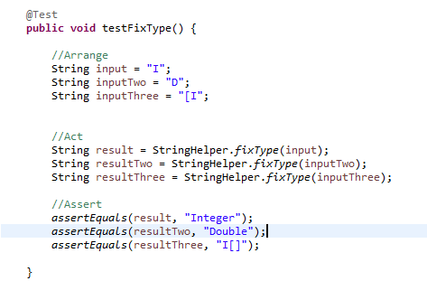

Code Listing - Example unit test

Using this pattern provided several benefits as it allows for clarification between the function being tested and setup and verification of the tests, by utilising a pattern when unit testing it became possible to ensure that all unit tests were constructed in a similar manner which emphasises system testing whilst maintaining a degree of readability. The unit tests were used to test the string handling methods handled in the utility classes and attempt to test some of the utility methods throughout the utility classes.

## Unit Test Results

Figure 2 shows the results of unit testing. All tests but one passed as expected, the one that failed required a more complex GUI set up that was not anticipated, to pass this test an instance of a GUI would have to be created and passed as a parameter to the test.

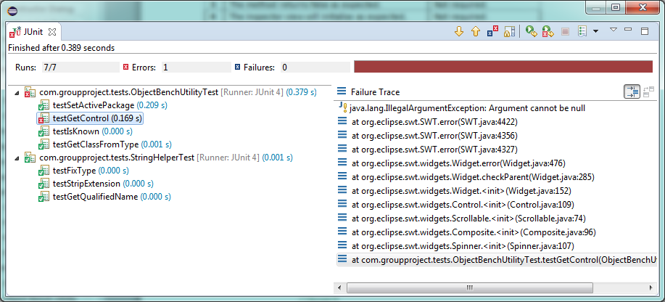

Figure - The results of Unit Testing

The test names correspond to the methods found within the classes ObjectBenchUtility and StringHelper, these tests are designed to enable the validation of key methods within the highlighted utility classes of the plugin.

# Beta Testing

## Client & User Feedback

This section will sum up the results from the beta test that was performed on the 26th of March 2015.

There were 7 participants; the following were some of the courses that the participants were on.

* BSc Computer Games Programming
* MEng Software Engineering
* MEng Computing Science
* MSc Information Systems Management
* MSC Network Tech & Management

There following questions and results will be shown below:

1. How strong is your knowledge in programming?
2. Have you ever used BlueJ?
3. How easy did you find to use the plugin?
4. Do you agree that the plugin was intuitive to use?
5. Do you agree that the plugin could be useful for beginners in programming?

The last question of the beta test was for the participants to add any further feedback.

Most of the answers to this were about some fixes needed for the GUI. This has been fixed by now.

However there were some very interesting comments highlighted below,

*“For someone with little programming knowledge I still could easily understand the functionality of the program”*

*“I had very little prior experience in programming in blue J and eclipse before the beta test, with that said within five minutes I learned about classes, instances, dependencies & inheritance visually via a class diagram from the plugin.”*

*“I really like the fact that you can change variables values without the need of going into the code.”*

# Observations During Testing

During testing a few observations were made outside of the test parameters, these observations were:

* **GUI Issues –** A few GUI issues were spotted such as missing titles for dialogs, slight dispositioning of icons and render issues within the class diagram related to lines, the majority of these issues are cosmetic but would need to be fixed for a final release.
* **Template Issues –** A couple of templates need tweaking to ensure correct functionality and to be better suited to purpose.
* **Spelling & Grammar –** There are a few instances of spelling and grammar mistakes throughout the system, like the GUI issues these will need to be addressed before a final release.

# Educational Testing

To test the products usefulness the following tests will be conducted by following the tutorials of a first year programming module. Each weeks exercise will be performed using the eclipse plugin, screenshots will be provided for proof. The usefulness of the product while working through the tutorials will be judged on the follow two criteria:

* How much of the tutorial exercise was accomplished using the plugin
* Whether the plugin made it easier / quicker to finish the exercise

A brief conclusion will be provided at the end of each week to sum up the usefulness of the plugin.

### Week 1

This was the first week of the module and therefore an introduction was given on how to use the class diagram and object bench within BlueJ.

The first exercise was to use the circle class and instantiate it. Figure 83 shows the representation of the classes. Figure 84 shows how the circle class is instantiated. Figure 85 is the Circle class instantiated on the object bench. Next it was instructed to call the makeVisible method; the output is shown in figure 86.

Next was instructed to use the moveHorizontal method (figure 87), in figure 88 you can see the input of 50 and the moved circle accordingly. Next exercise was to call changeColor to change the circle to red, proof in figure 89.

The second part of the tutorial was to work on the house project. The class diagram for this is shown in figure 90. The task was to add another sun (circle) in the picture class, figure 91. Figure 92 shows the output with the second circle when calling the runDemo method on picture class.

Third part of the tutorial was to work on the lab student project. First task was to instantiate some student classes, figure 93 shows the pop up of entering student name and id when instantiating student class. Next it was required to perform a getName method of student class on object bench; this is shown in figure 94 and 95. Next it was required to instantiate a lab class and calls its getStudentNumber method, figure 96.  
Next enrolling a student to a lab was required; figure 97 shows enrolStudent methods output where the available students on the object bench are shown. Figure 98 shows the output of calling currentStudents method in lab class.

This week’s tutorial was fully accomplished with the eclipse plugin and was quick and easy to use. Therefore it was useful to use in performing week 1’s tutorial exercises.

### Week 2

In the second week the tasks involved working and playing around with the ticket machine project.

First it was instructed to instantiate a ticket class and enters the ticket price; this is shown in figure 99. Figure 100 shows the available methods of ticket class; figure 101 shows the output for calling getPrice method. Next was instructed to print a ticket by calling the printTicket method, output is shown in figure 102. Next task was to get current balance of the ticket machine which after printing as ticket should be 0 as shown in figure 103.

This week’s tutorial questions were answered fully by using the eclipse plugin and was quick and easy to use, therefore it stands that the plugin was useful when completing week 2’s tutorial.

### Week 3

Most questions this week required answers without using an IDE and therefore there are no examples of using the object bench plugin.

### Week 4

Week 4 was mainly full of exercises that didn’t need an IDE answering, however one question required adding a method which emptied the ticket machine, displaying the earning and the balance. This is showing in figure 104.

This week’s BlueJ tutorial questions were answered fully by using the eclipse plugin and was quick and easy to use, therefore it stands that the plugin was useful when completing week 4’s tutorial.

### Week 5

Week 5’s questions also involved non IDE questions; however some of the BlueJ questions were for using the ClockDisplay project.

Figure 105 shows the class diagram and class instantiated for the ClockDisplay project. Figure 106 shows the values for when the clockDisplay is instantiated. Figure 107 shows the available methods.

Next task was to make the clock tick by one second, this is done by calling the timeTick method, and output is shown in figure 108.

Last task was to set the time, this was done by calling setTime method, and output is shown in figure 109.

Again using the plugin for this week’s exercises proved useful.

### Week 6

This week’s tutorial was about using JUnit testing which our plugin does not support and therefore was unable to be used to perform the questions.

For this week the plugin was not useful as none of the JUnit testing questions could be answered by using the plugin.

### Week 7

Week 7 was a reading week and therefore no classes were held.

### Week 8

Week 8’s exercise involved working with the club project.

Figure 110 shows the first task which was to add a join method.

Next task was to instantiate a membership, this is shown in figure 111. Figure 112 shows the object bench with the instantiated membership and club classes. The next task was to add a membership to an array within the club class; this was done by invoking the join method. Figure 113 shows the prompt for this by selecting a membership on the object bench.

The plugin was used and allowed to finish all the tutorial tasks in a useful and quick manner.

### Week 9

Same as week 6.

### week 10

Week 10’s Blue J exercise involved using the Test project. It was to introduce behaviours of loops in java to the students.

Figure 114 shows the available methods of the Test class.

The next task was to call the looperOR method; the output is shown in figure 115. The last task was to invoke the looperAND method; output was shown in figure 116.

The plugin again was useful in performing the tutorials exercises.

### week 11

Same as week 6.

### Week 12

This week’s tutorial BlueJ exercises involved working with the weblog analyser project. Class diagram for this is shown in figure 117.

The one task was to change a “for” loop to a “while” loop. This was done and is shown in figure 118.

The plugin was useful for this week’s IDE exercise as the exercise was completed.

### Week 13

From Week 13 onwards the students were moved onto using eclipse. The plugin is intended to replace BlueJ but as a proof of concept the plugin will be used to answer this week’s questions. The other following weeks will not be attempted.

This week’s exercise was to work with the Support System project.

The first task was to start the supportSystem class and play around with it by writing inputs. This can all be seen in figure 119. The next task was to add a trim method to remove any white space after an input, this is seen in figure 120. The proof of it working is shown in figure 121 and 122.

The last task was to change the code so that the input for bye which ends the support system is case insensitive. This was done by changing the match statement to equalsignroecase as seen in figure 123. Figure 124 is proof of it working.

The plugin definitely once again proved to be useful when completing the tutorials exercises; it was quick and easy to use. Therefore it is again deemed to be useful for completing the tutorials questions.

## Educational testing Conclusion

Overall the eclipse plugin worked perfectly in completing the questions from the first year module, using the plugin instead of BlueJ is viable. However the only issue is that no JUnit testing questions were able to be answered. This however was very dependent on BlueJ, other testing questions could have been formed which would work with the eclipse plugin.

In conclusion the eclipse plugin proved to be useful in performing the educational test.

# Action Plan

As a result of testing it is clear that before a final version of the software can be released there are a number of issues that need to be addressed. As a result of testing the team will look to move forward with the project with work in the following areas:

* Bug Fixes
* Improvements based on feedback.
* Completing documentation & training material.

Each team member should look to contribute to the completion of each area to ensure the highest quality release possible. All bugs should be addressed and all of these areas must be completed before the product can be released to both the client and audience.

# Conclusions

Through testing the software it was possible to determine any bugs and issues that can be found throughout the system. By enabling potential end users the opportunity to use the system and give us critical feedback we can now look to improve the system and ensure a good sense of stability for a final release. The value of the software has been validated and through testing its use in an educational setting it has been possible to prove that the plugin has value within the educational sector. A result of this is that the software is of a clear benefit to new programmers and programmers transitioning from a beginner environment into a professional one.

# Appendix A: Test Screenshots

## Object Bench

### Test 1

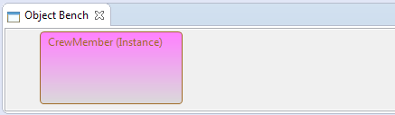

Figure - Before deleted instance.

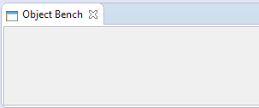

Figure - After deleted instance.

### Test 2



Figure - Before clearing.



Figure - After clearing.

### Test 3

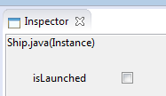

Figure - Before the method call.

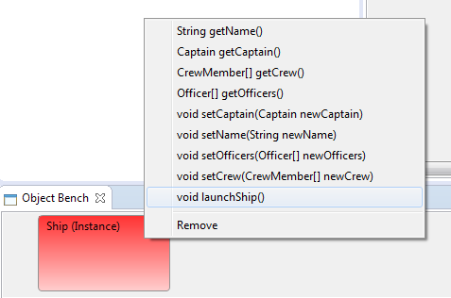

Figure - Calling the method

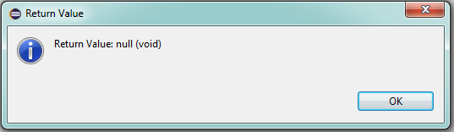

Figure - Example return dialog.

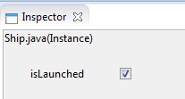

Figure - Value after method call.

### Test 4

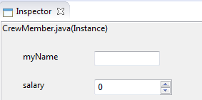

Figure - Before method call.

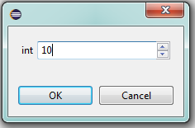

Figure - Taking a parameter.

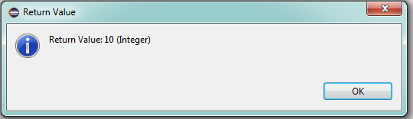

Figure - The return value of the method.

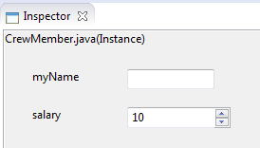

Figure - After method call, value is changed as expected.

### Test 5

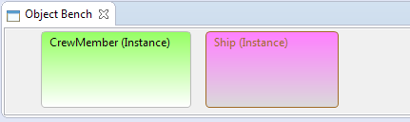

Figure - Selected instance in pink.

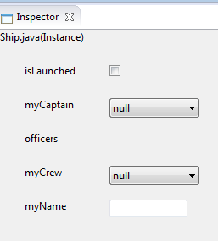

Figure - The values of the instance in the inspector.

### Test 7

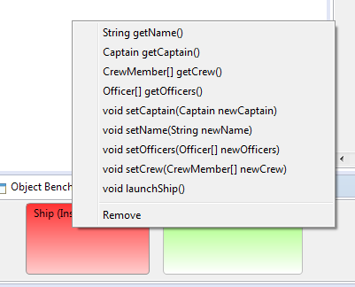

Figure - Showing the available methods in a context menu.

## Class Diagram

### Test 1

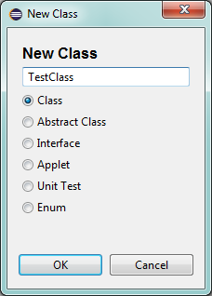

Figure - Creating a new Class

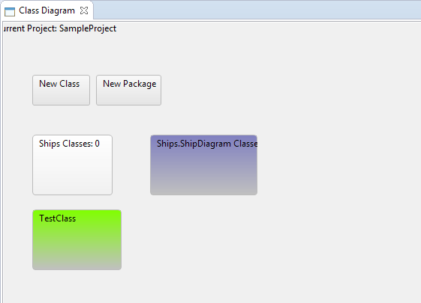

Figure - The class is added to the diagram.

### Test 2

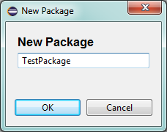

Figure - Creating the test package.

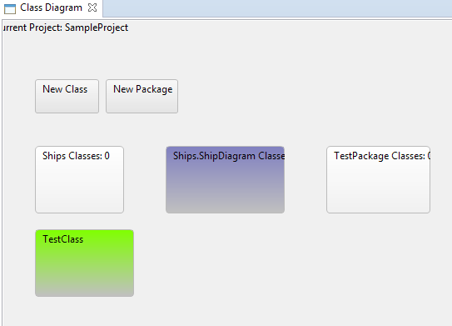

Figure - The package is added.

### Test 3

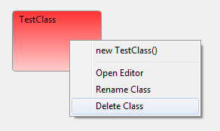

Figure - Preparing to delete class.

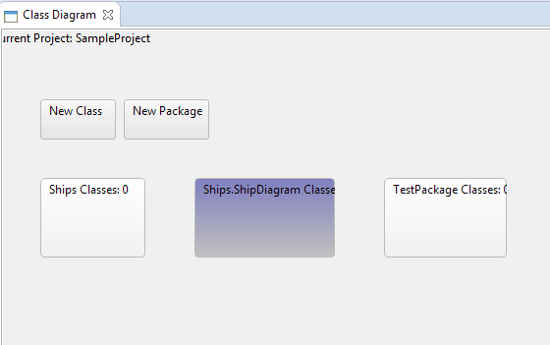

Figure - After class deletion.

### Test 4

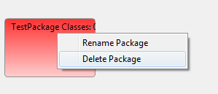

Figure - Preparing to delete package.

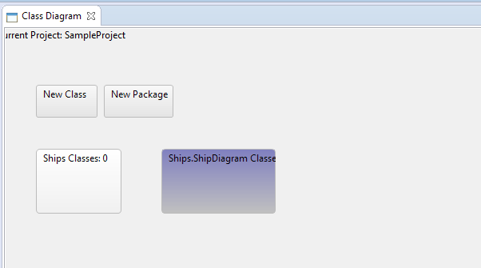

Figure - Class diagram after package deleted.

### Test 5

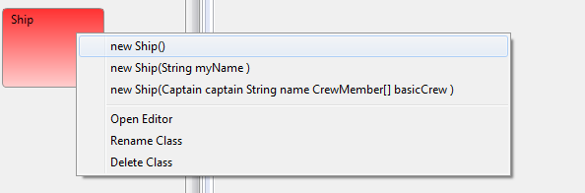

Figure - Calling the constructor.

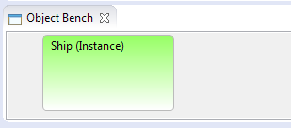

Figure - Instance added to bench.

### Test 6

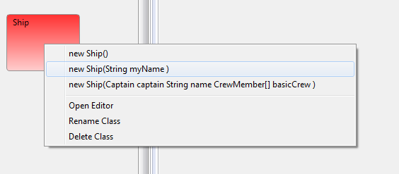

Figure - Selecting the constructor.

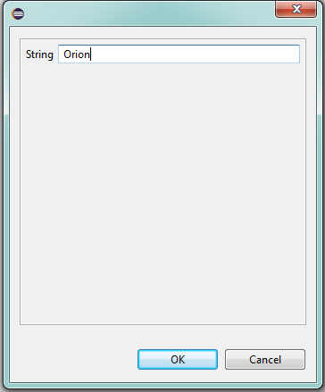

Figure - Entering the parameter.

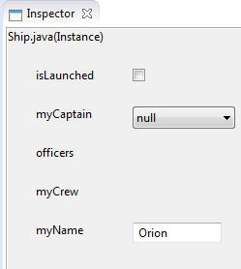

Figure - The instance is created and the parameter is used.

### Test 7

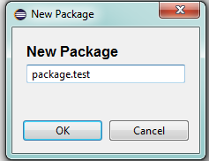

Figure - Entering package name.

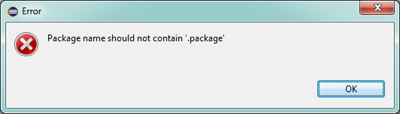

Figure - Package name rejected as expected.

### Test 8

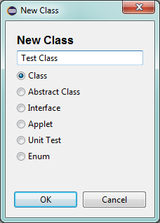

Figure - Entering the class name.

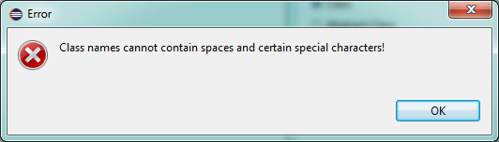

Figure - The class name is rejected as expected.

### Test 12

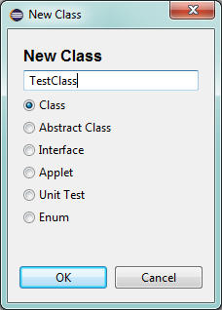

Figure - Entering a class for creation, this is done twice.

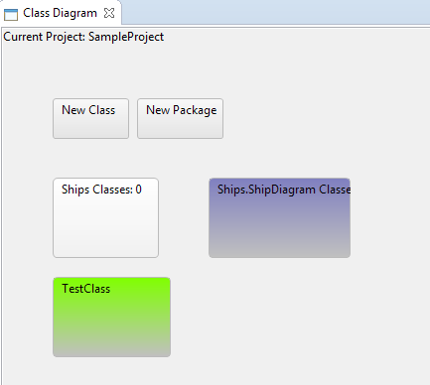

Figure - There is no error and the system seems to accept a duplicate class.

### Test 14

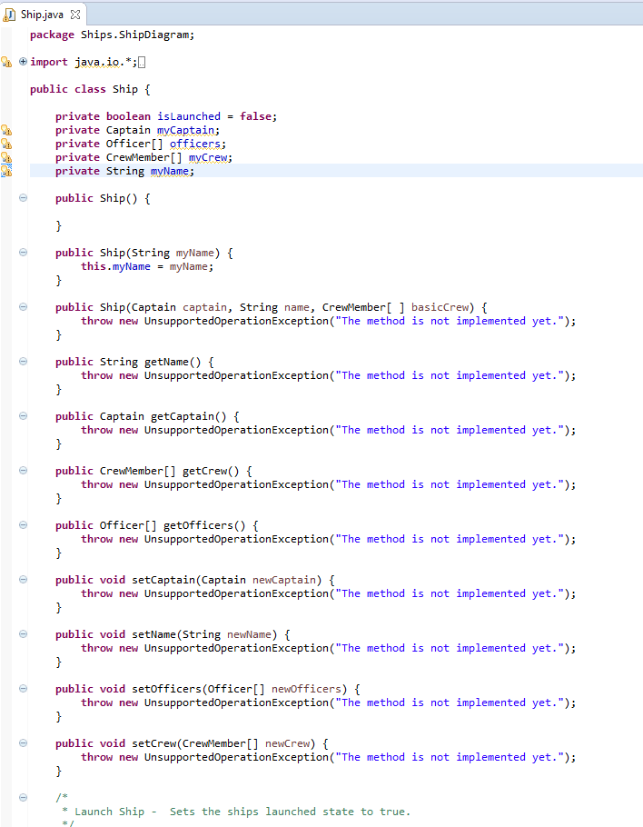

Figure - The editor is opened as expected.

### Test 15

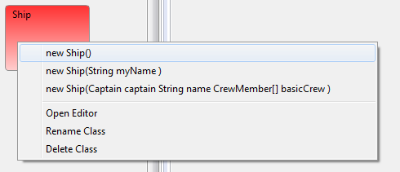

Figure - All "Ship" constructors are present as expected.

## Inspector

### Test 1

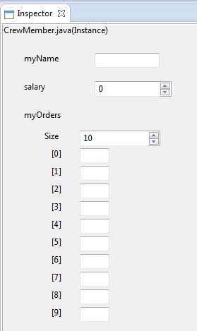

Figure - An instance viewable in the inspector.

### Test 2

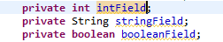

Figure - The field types.

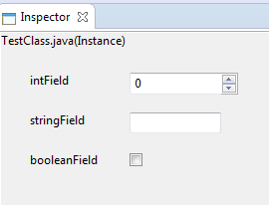

Figure - As expected a Spinner, TextField and CheckBox are created.

### Test 3

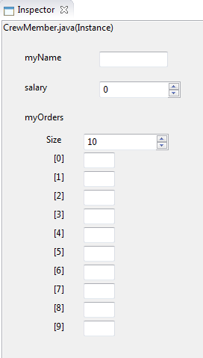

Figure - The instance before editing the array.

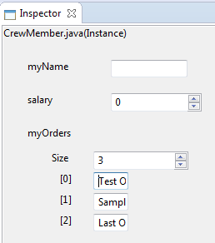

Figure - After editing the array, field controls need to be made bigger.

### Test 4

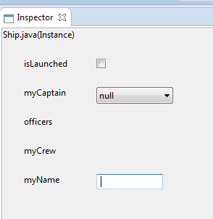

Figure - Before naming the ship.

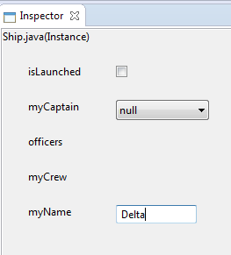

Figure - After naming the ship.

### Test 5

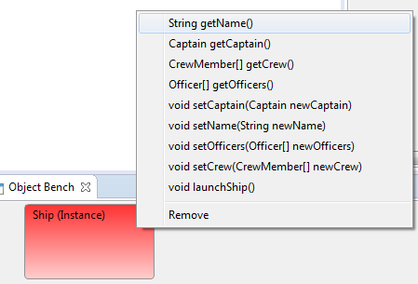

Figure - Selecting the getName method.

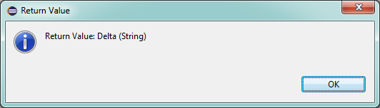

Figure - Getting the correct return value as expected.

### Test 6

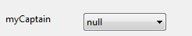

Figure - Field before setting the value.

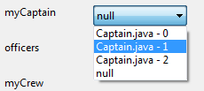

Figure - Selecting the captain.

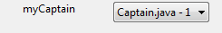

Figure - After setting the captain value. This is the second instance as wanted.

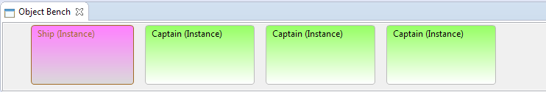

Figure - Showing the object bench.

## Constructor Dialog

### Test 1

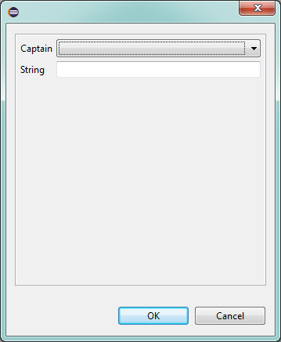

Figure - The correct controls are provided as expected.

### Test 2

No screenshot, but the test was successful.

### Test 3

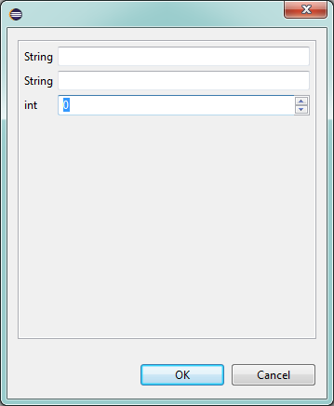

Figure - The field won't allow text entry.

### Test 4

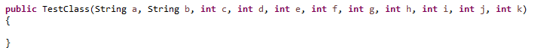

Figure - The constructor signature.

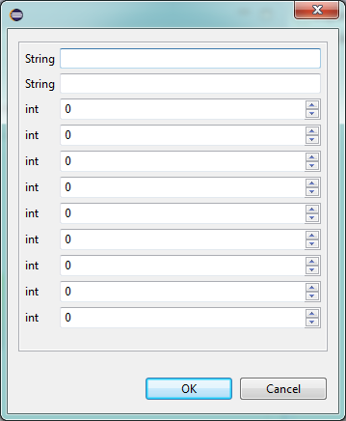

Figure - The correct controls for the long constructor.

### Test 5

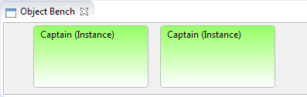

Figure - The object bench containing captains.

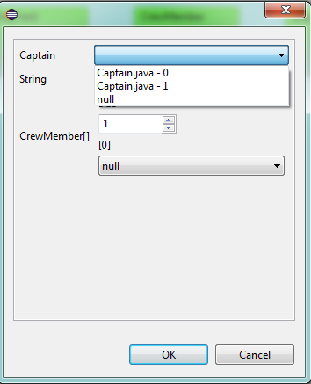

Figure - The captains selectable from the constructor dialog.

### Test 6

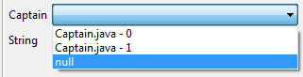

Figure - An instance field can be set to null.

## Method Call Dialog

### Test 1

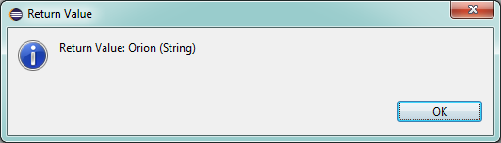

Figure - Getting the return value from a called method.

### Test 2

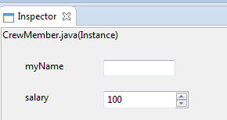

Figure - Showing initial salary.

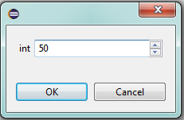

Figure - Adding to the salary by setting the parameter in the method call dialog.

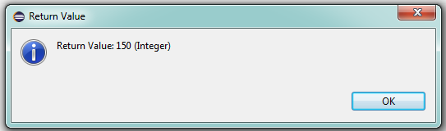

Figure - The return value of the method when called after confirming the method call dialog.

### Test 3

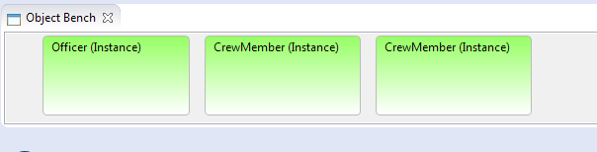

Figure - The Object bench prior.

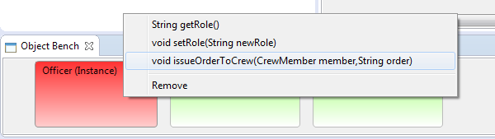

Figure - Preparing to call the method.

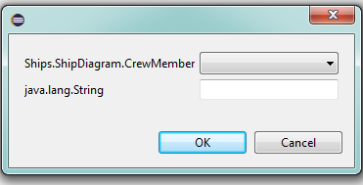

Figure - As expected the controls are a drop down for crew members and a text box for the order string.

### Test 4

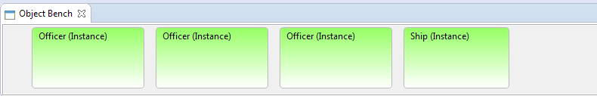

Figure - Setting up the object bench.

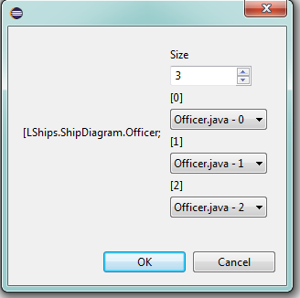

Figure - Setting the fields.

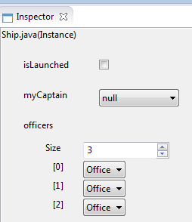

Figure - To show the array is set according to the fields entered in the method dialog.

## New Class Dialog

### Test 1

See Class Diagram Test 1.

### Test 2

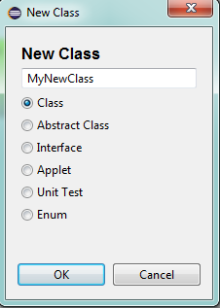

Figure - Selecting templates.

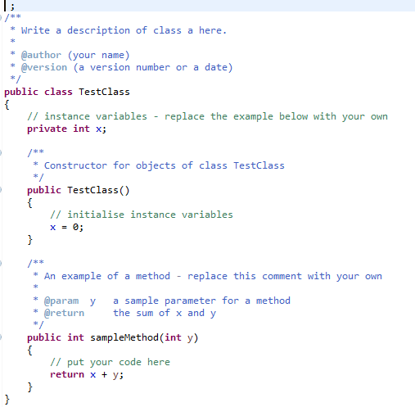

Figure - Default template.

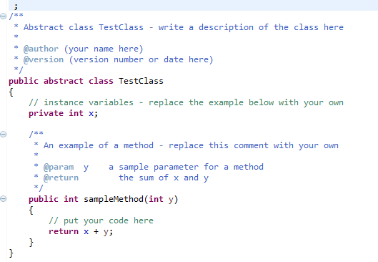

Figure - Abstract template.

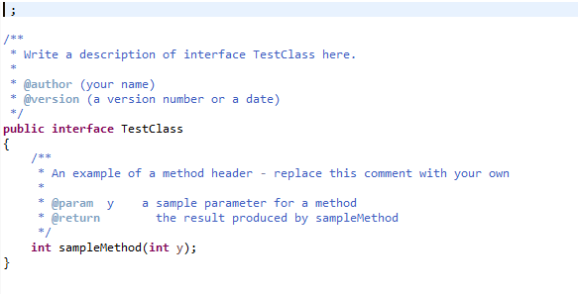

Figure - Interface template.

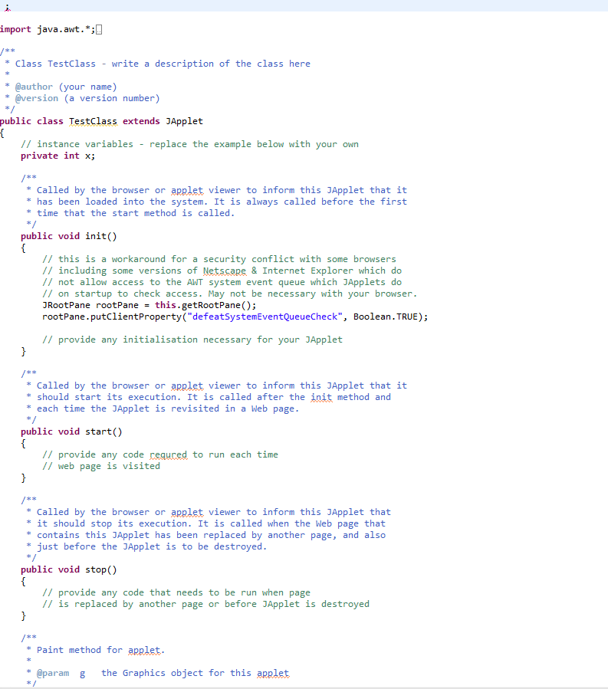

Figure - Applet template.

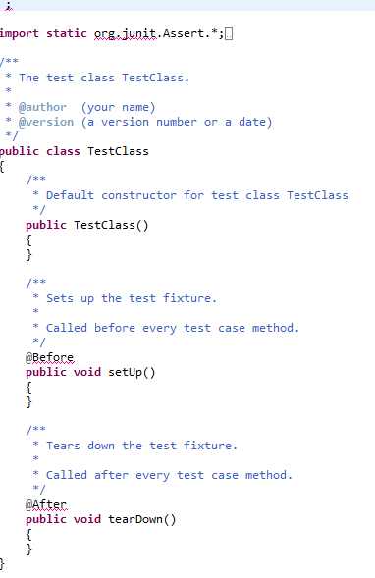

Figure - Unit test template.

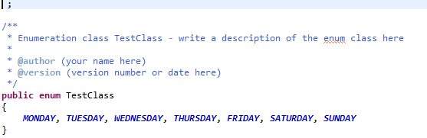

Figure - Enumeration template.

### Test 3

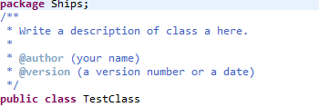

Figure - Both package and class name are correct.

## New Package Dialog

### Test 1

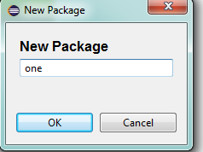

Figure - Package dialog for a new package.

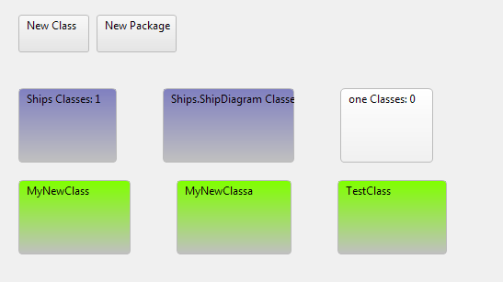

Figure - The new package "one" is created.

### Test 2

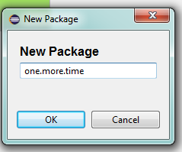

Figure - Creating a nested package with the new package dialog.

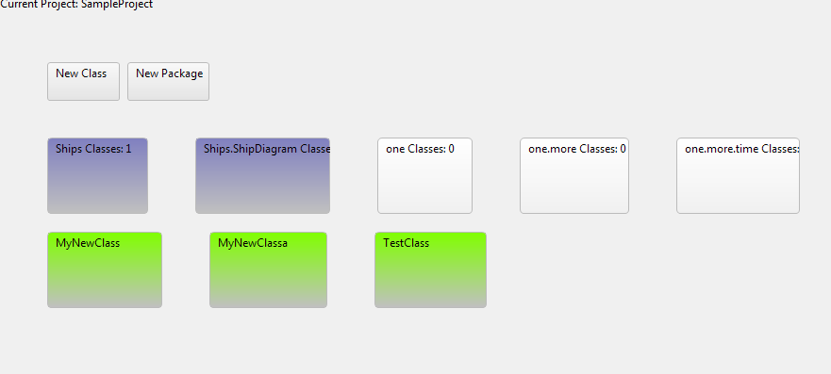

Figure -The new packages are added.

### Test 3

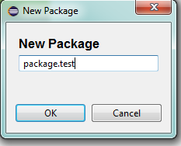

Figure - New package dialog testing if package can be included in the name.

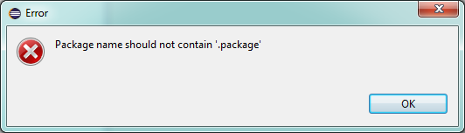

Figure - As expected an error dialog is created.

## Educational Testing

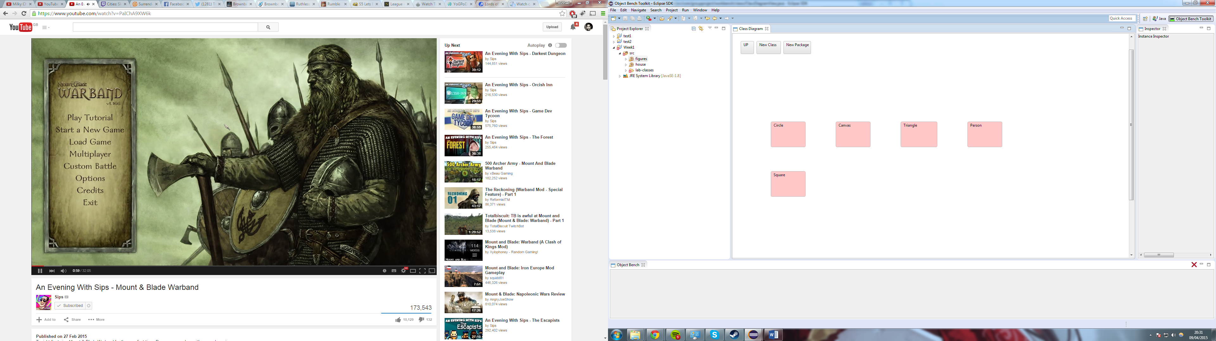 Figure – The first exercise class diagram.

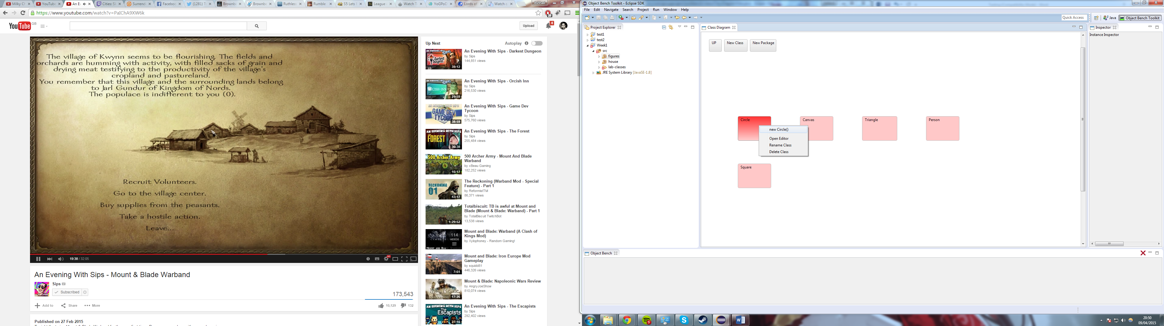

Figure 83 – Example of instantiating circle class via class diagram.

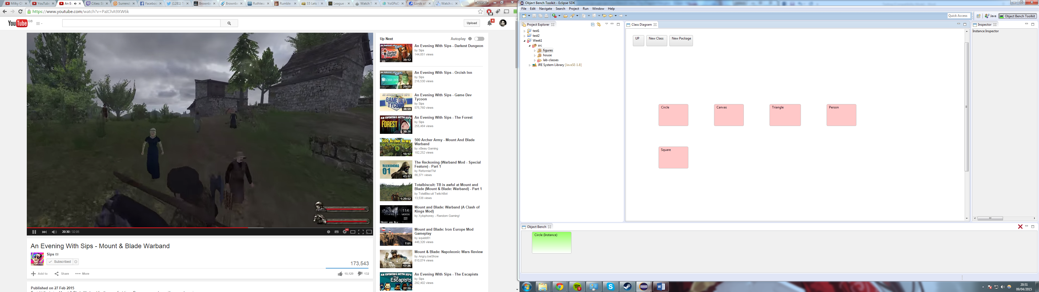

Figure 4 – The circle class on the object bench.

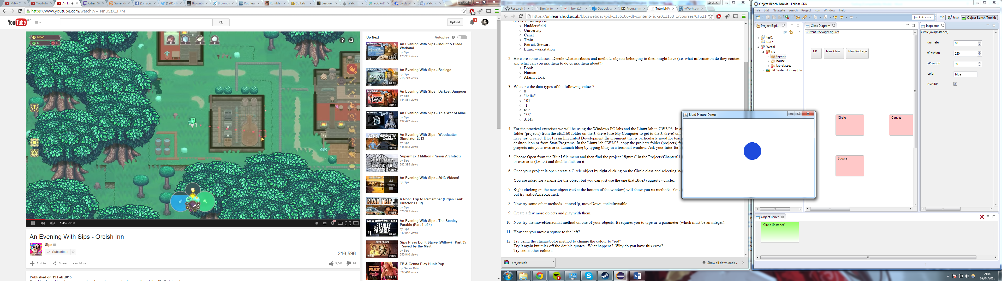

Figure 85 – The output of when makeVisible of the circle class is called.

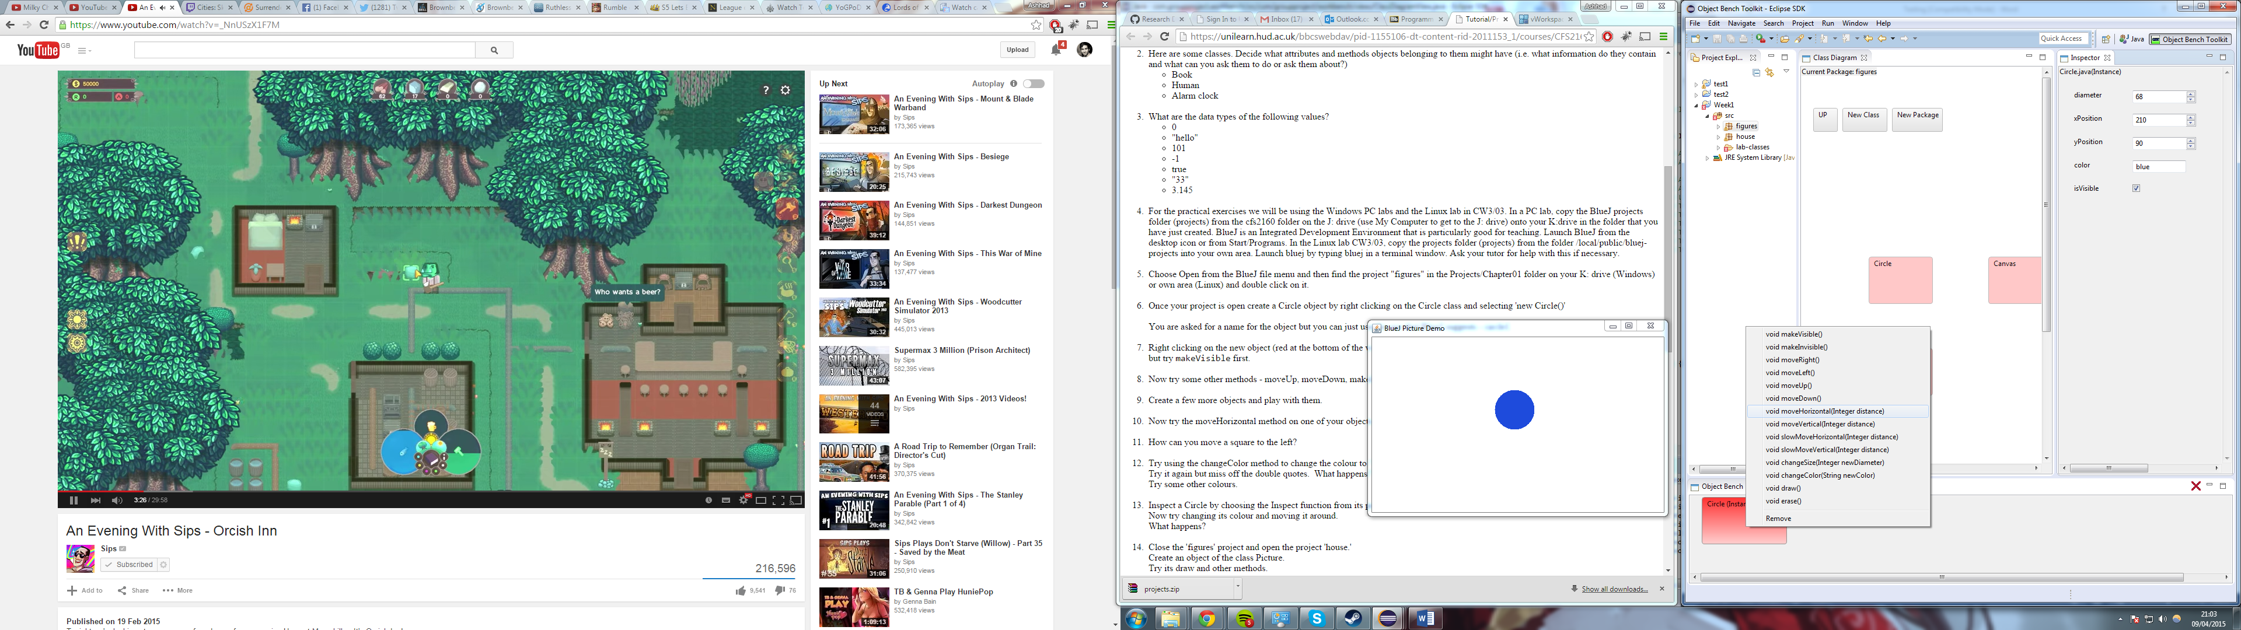

Figure 6 – The list of methods for circle instance.

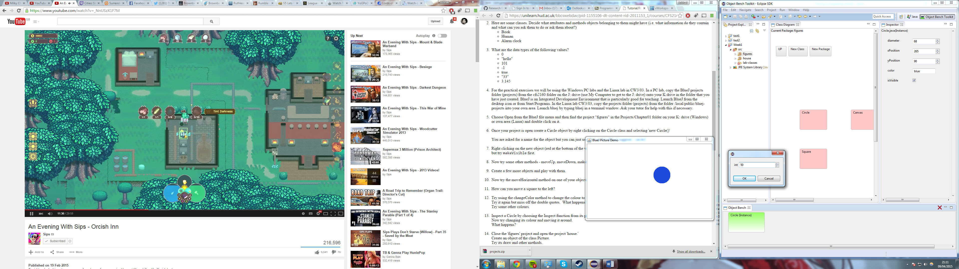

Figure 87 – Result of when moveHorizontal is called with input of 50.

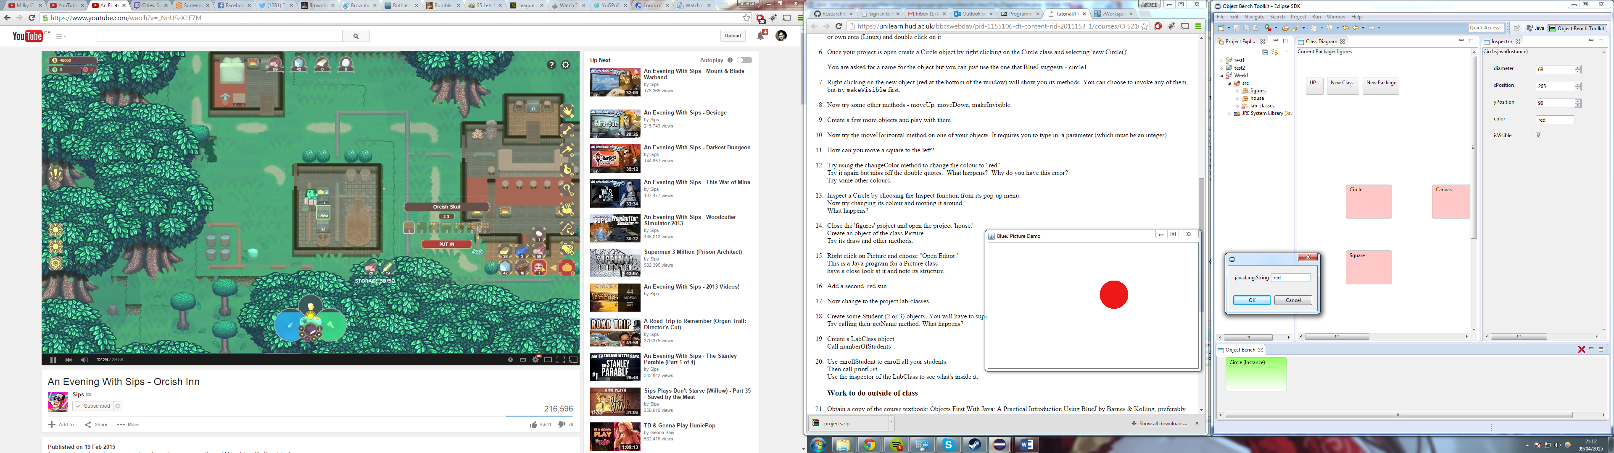

Figure 88 – Output of when changeColour is called, with input of red.

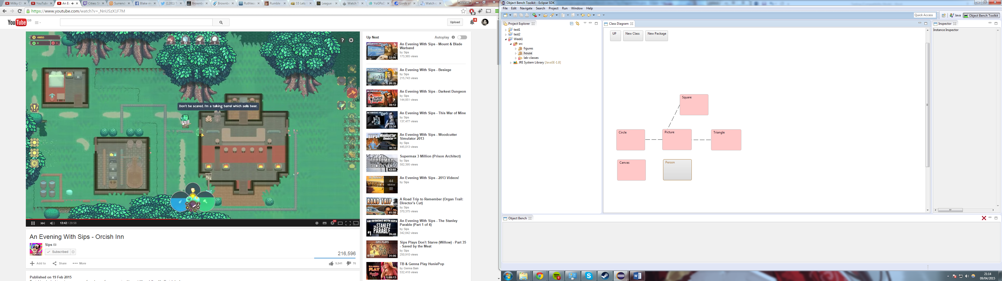

Figure 9 – The class diagram representation of opening the house project.

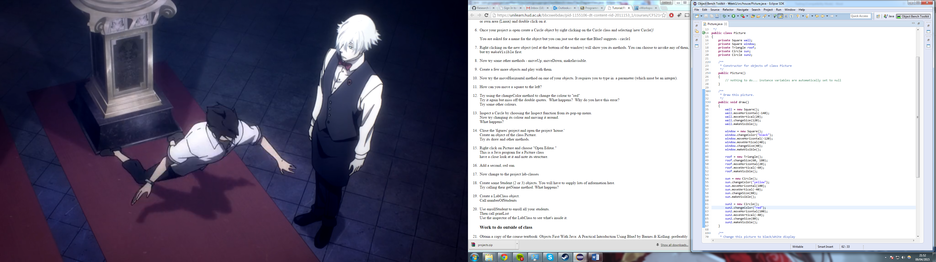

Figure 90 – The code editor with code for adding another red sun.

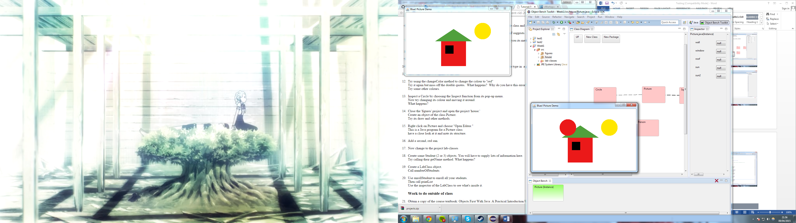

Figure 91 – The output of calling the demo method of picture class.

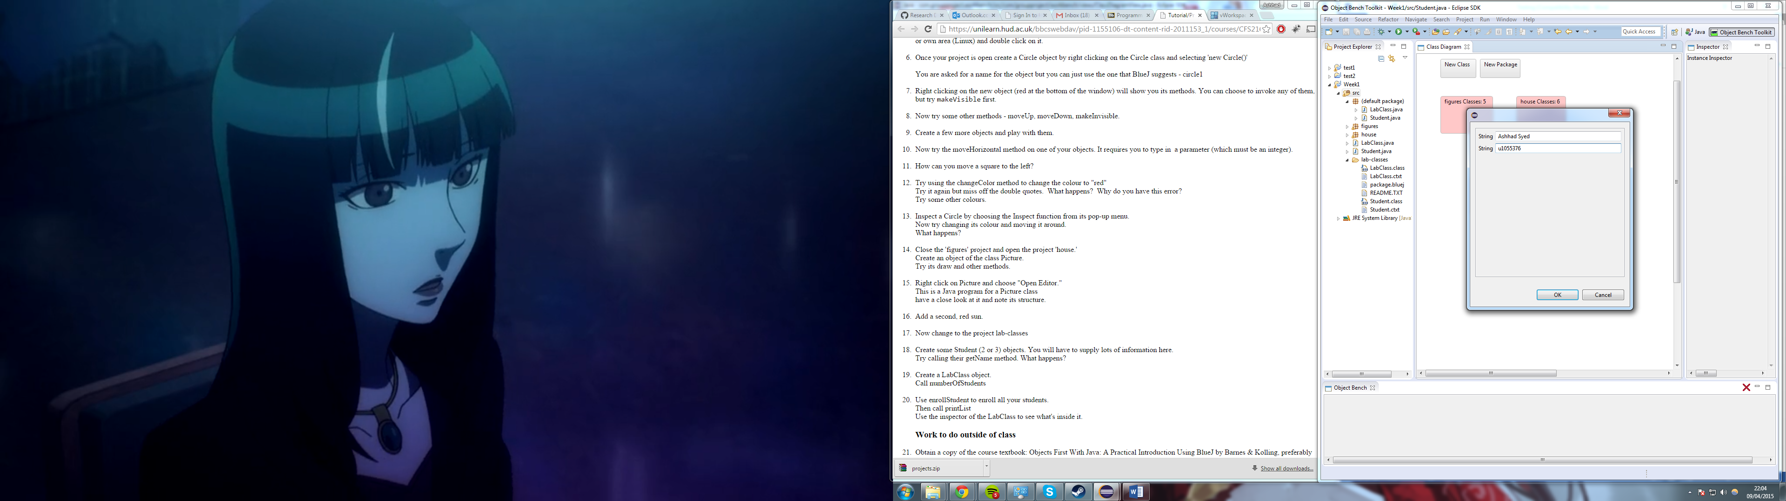

Figure 92 – the prompt for entering information when instantiating student class

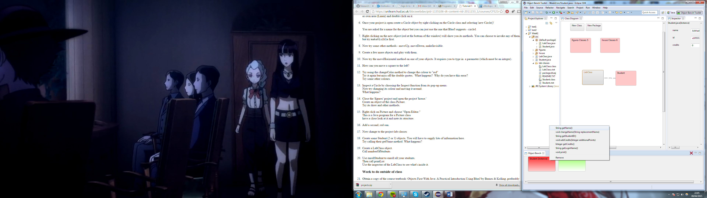

Figure 93 – Calling students getName method

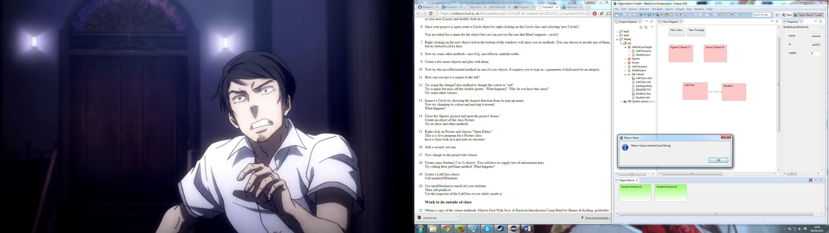

Figure 94 – The output for calling getName method

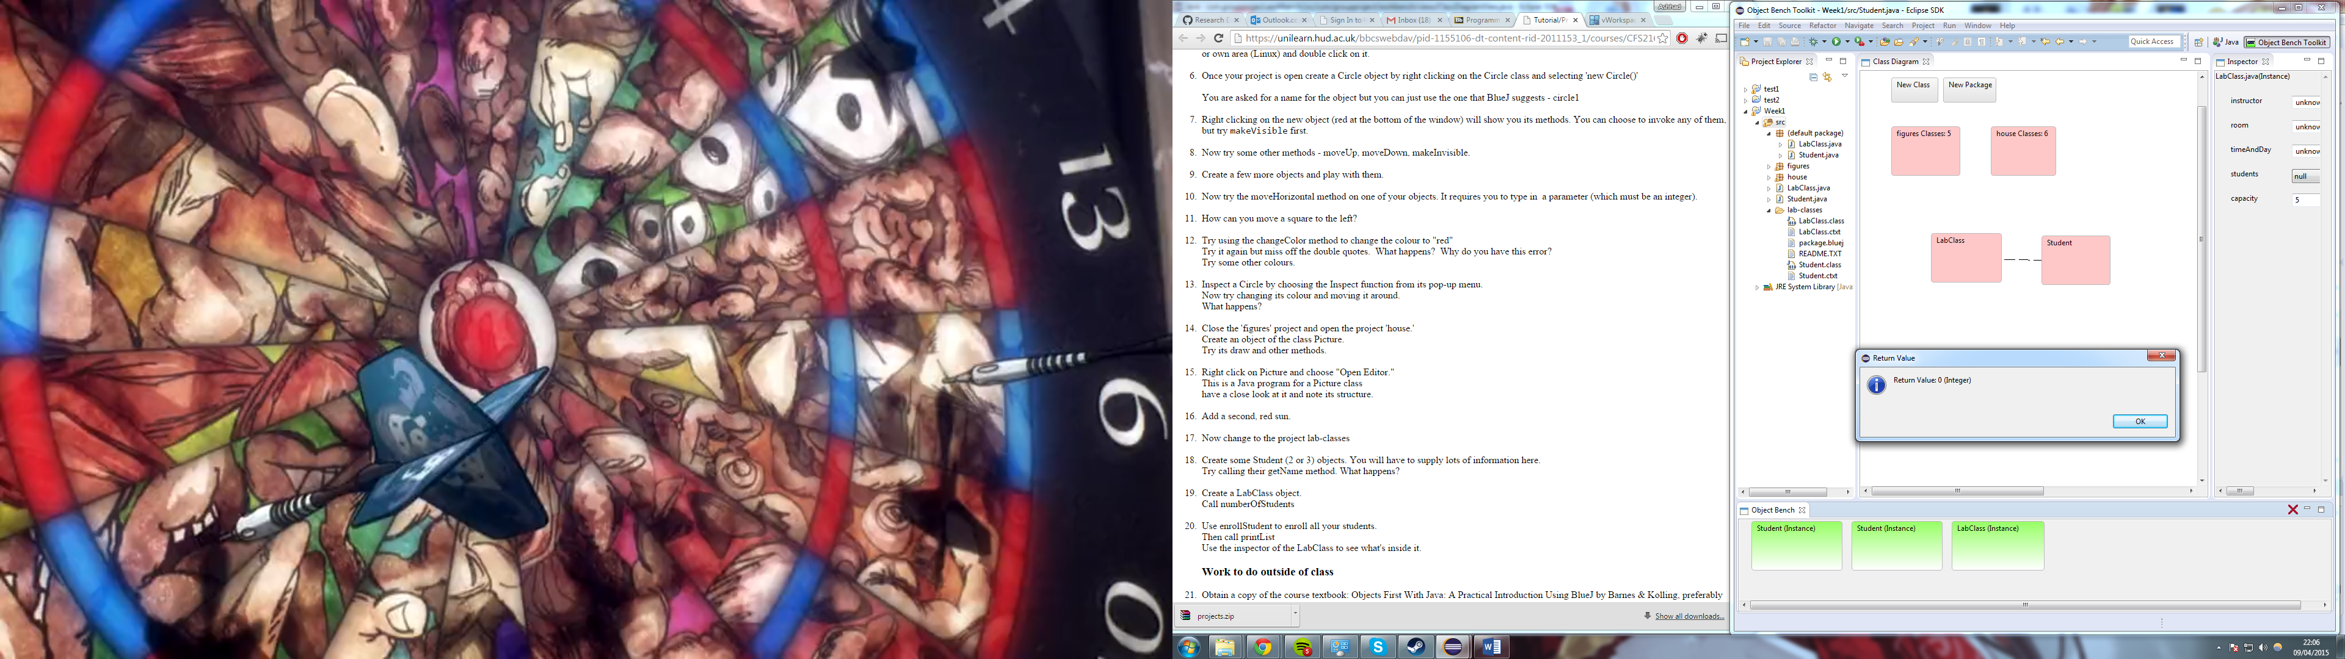

Figure 95 – The output for calling numberOfStudents method for LabClass

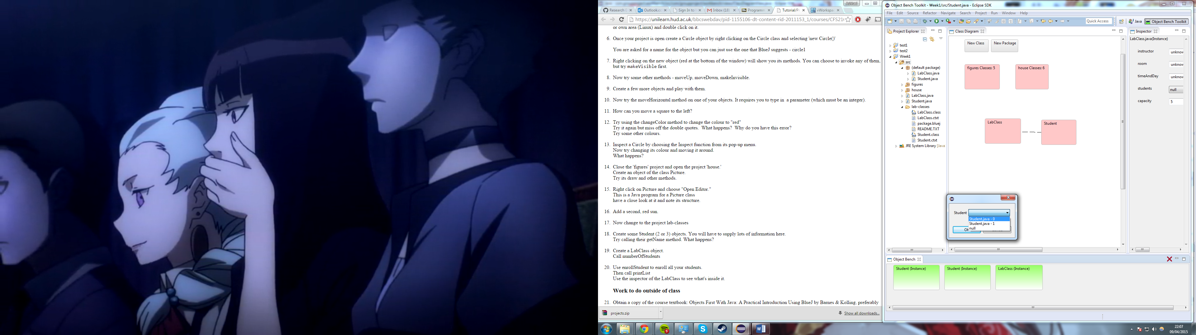

Figure – The output for calling enrollStudent method in LabClass. Option to select one of the 2 student instances

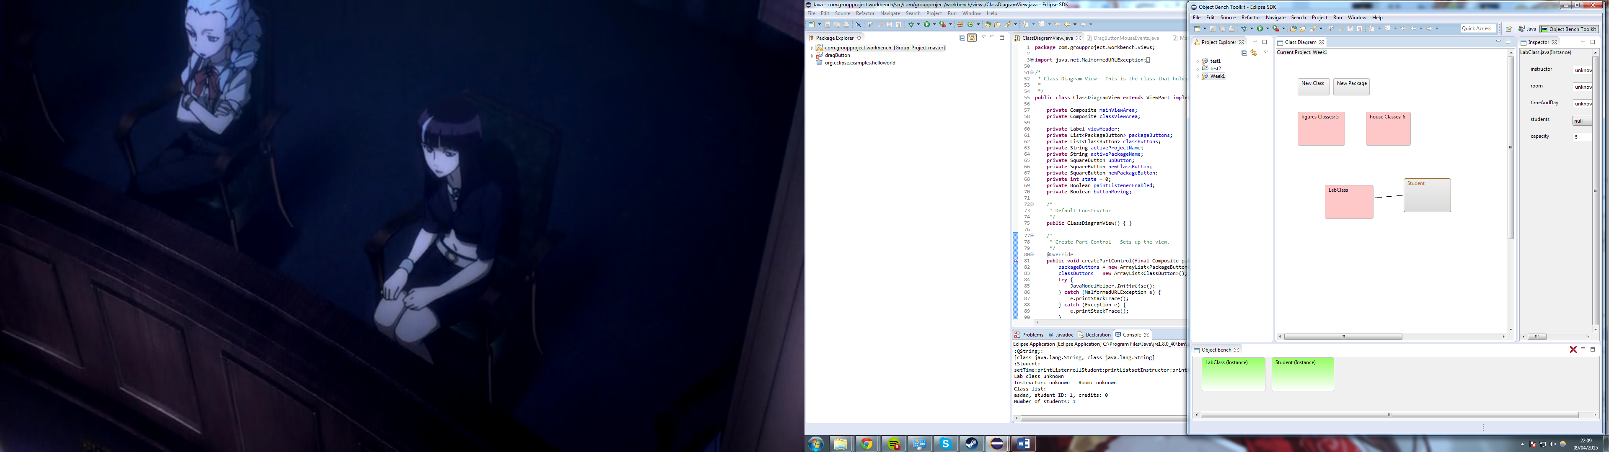

Figure 97 – Output for calling printList method for LabClass.

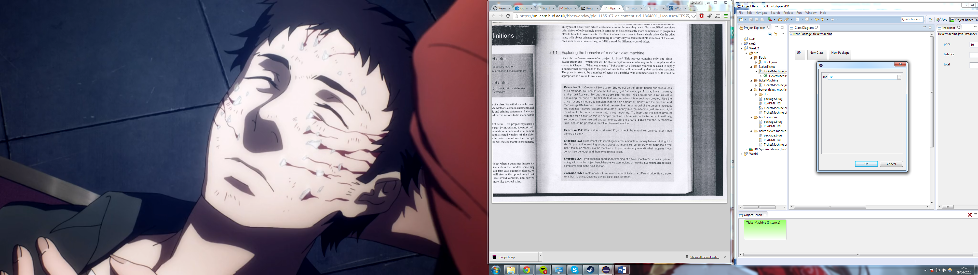 Figure 98 – Prompt for entering ticket price when instantiating ticket class

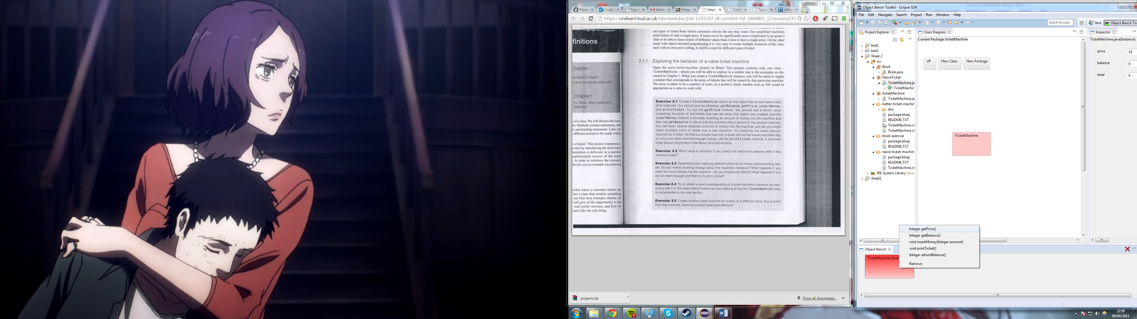

Figure 99 – Calling ticketMachines getPrice method

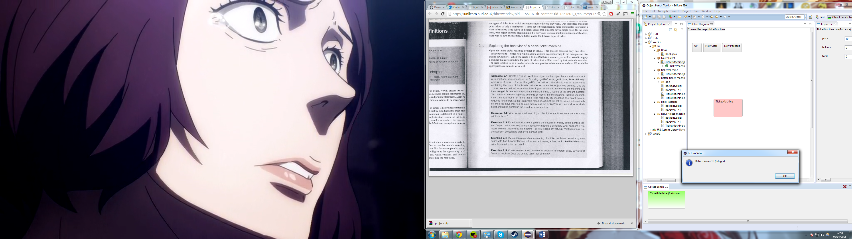

Figure 100 – The output for calling getPrice method

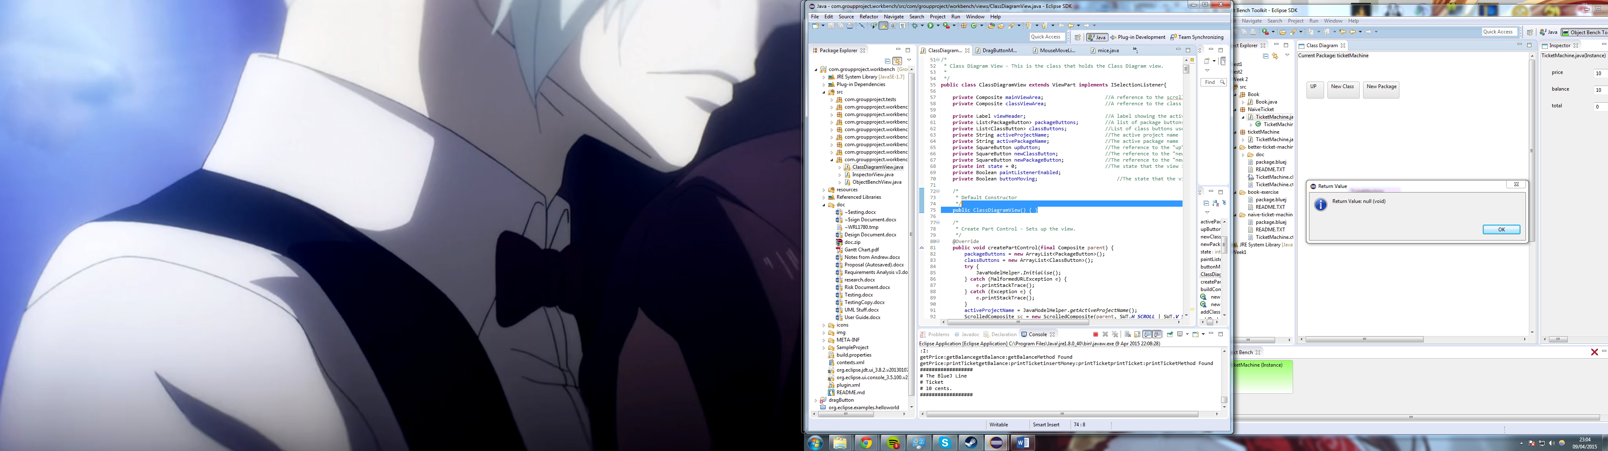

Figure 101 – Output for calling printTicket method.

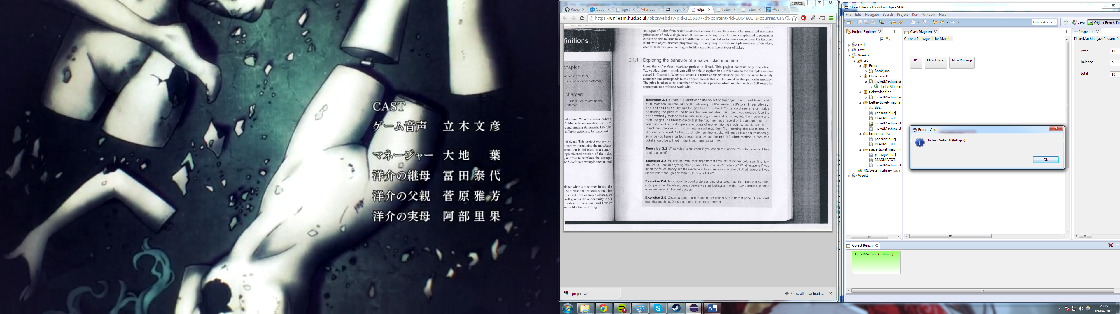

Figure 102 – Output for calling getBalance after printing a ticket.

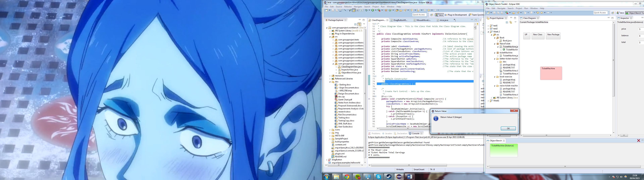

Figure 103 – The output for calling emptyMachine method.

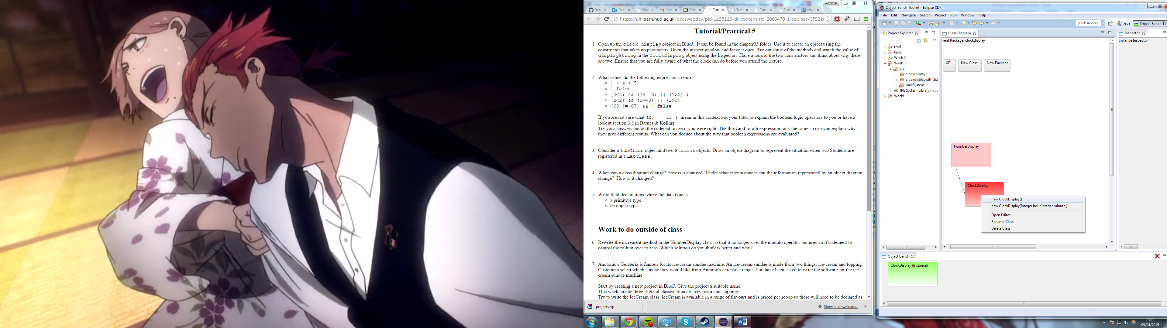

Figure 104 – ClockDisplay Project, with Class diagram and instantiation of ClockDisplay class

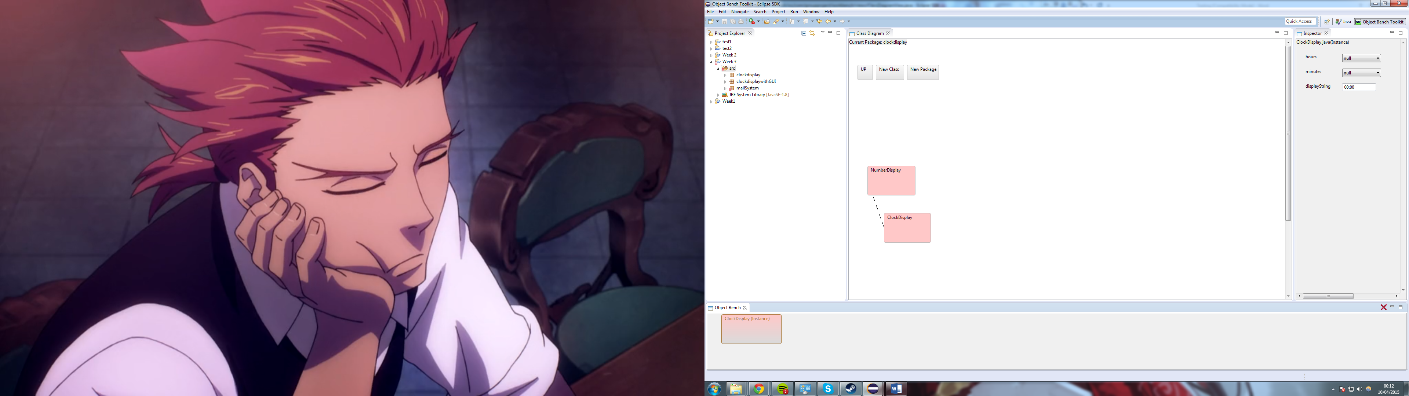

Figure 105 – Instantiated ClockDisplays current values on the inspector tab.

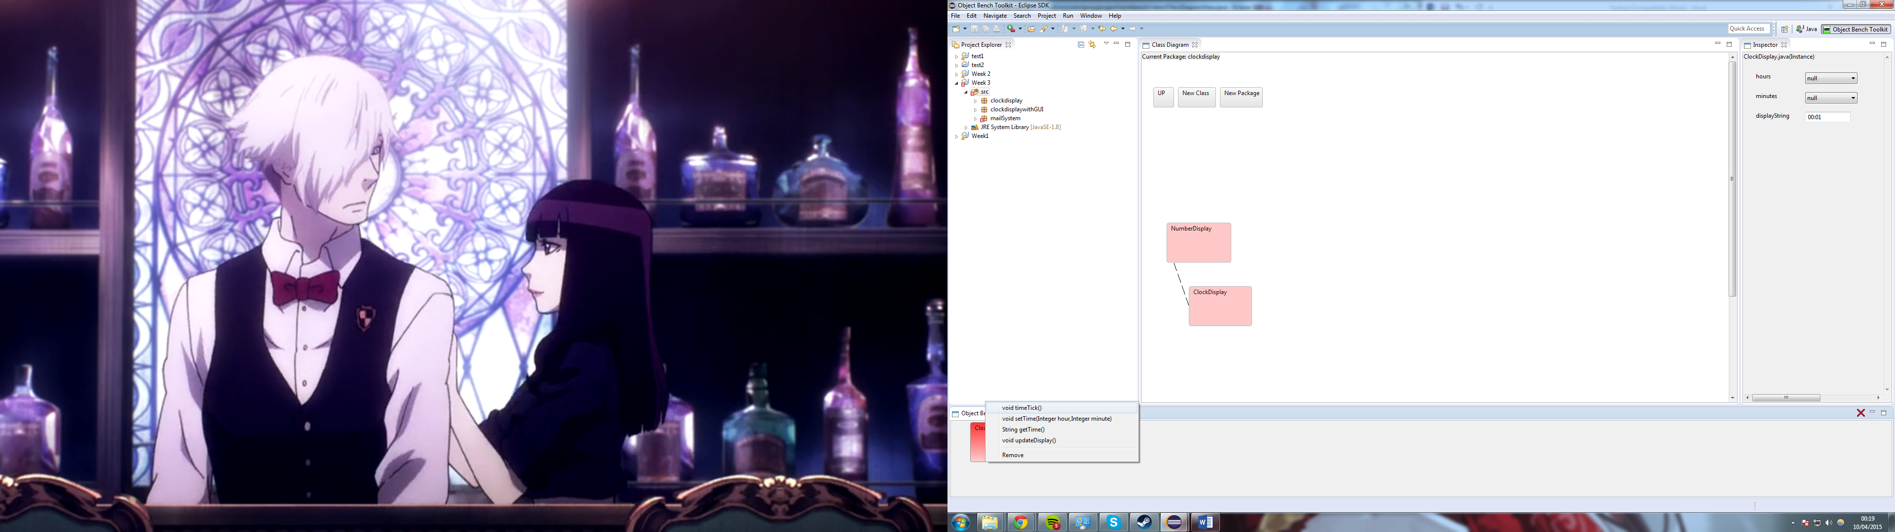

Figure 106 – Available methods of ClockDisplay

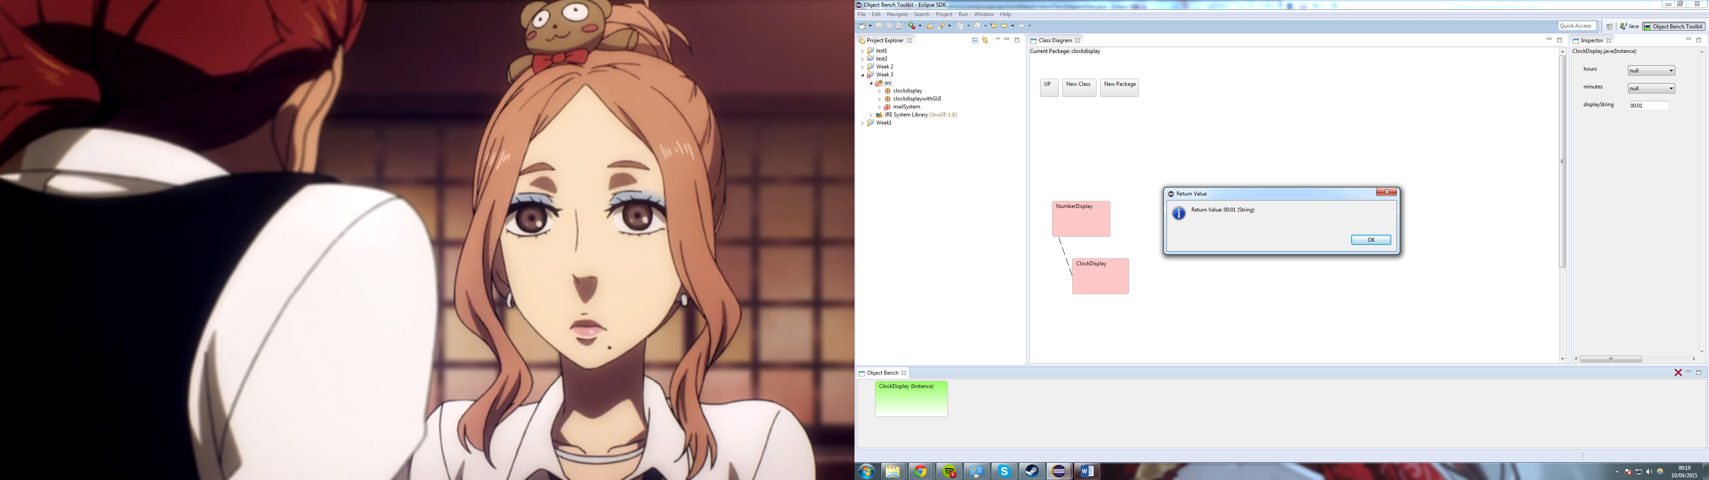

Figure 107 – Output for calling timeTick method.

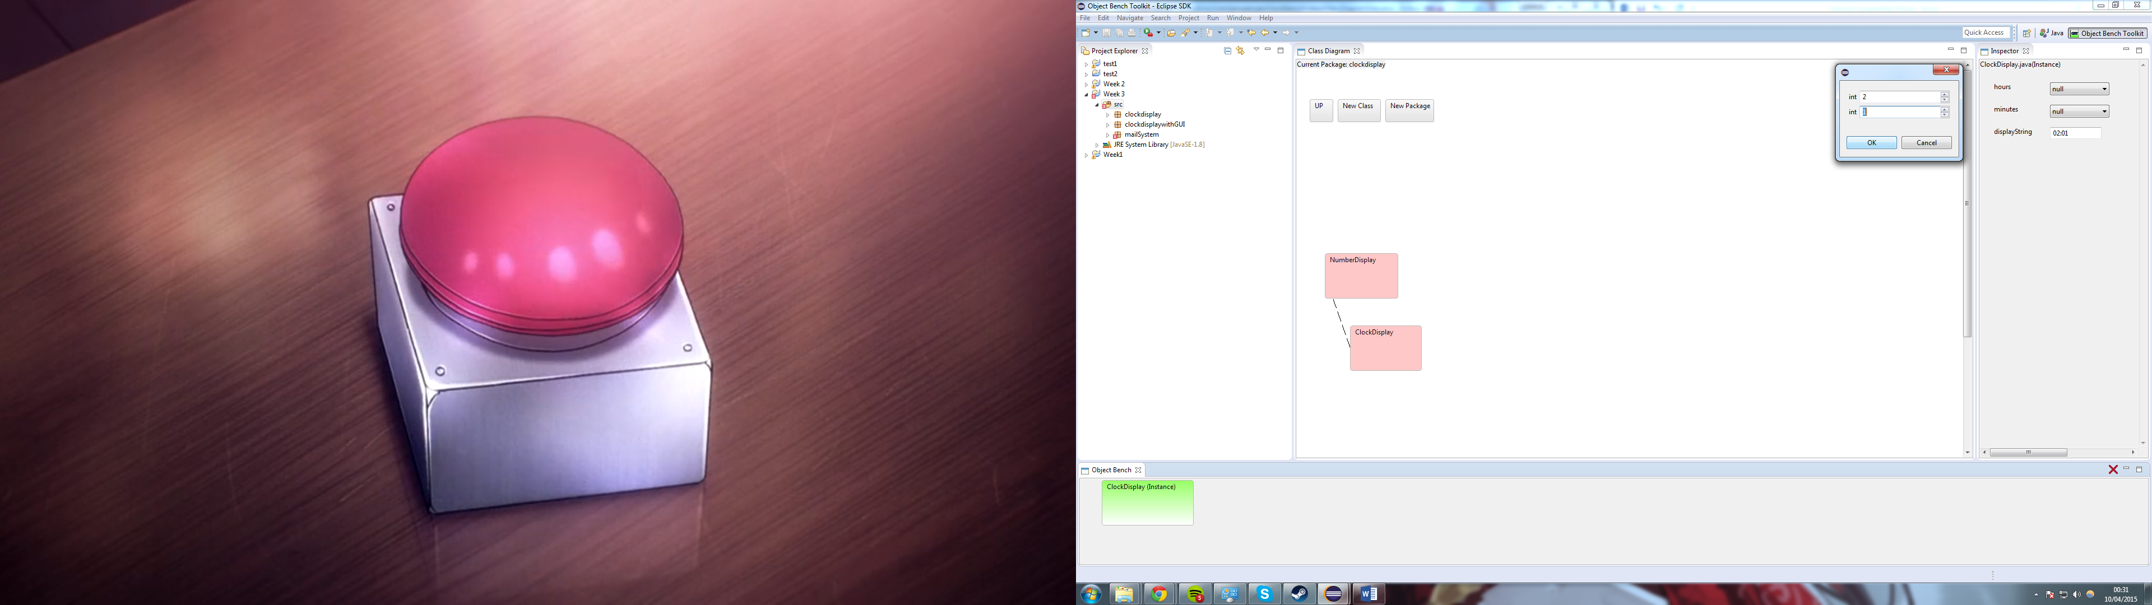

Figure 108 – Output for calling setTime method.

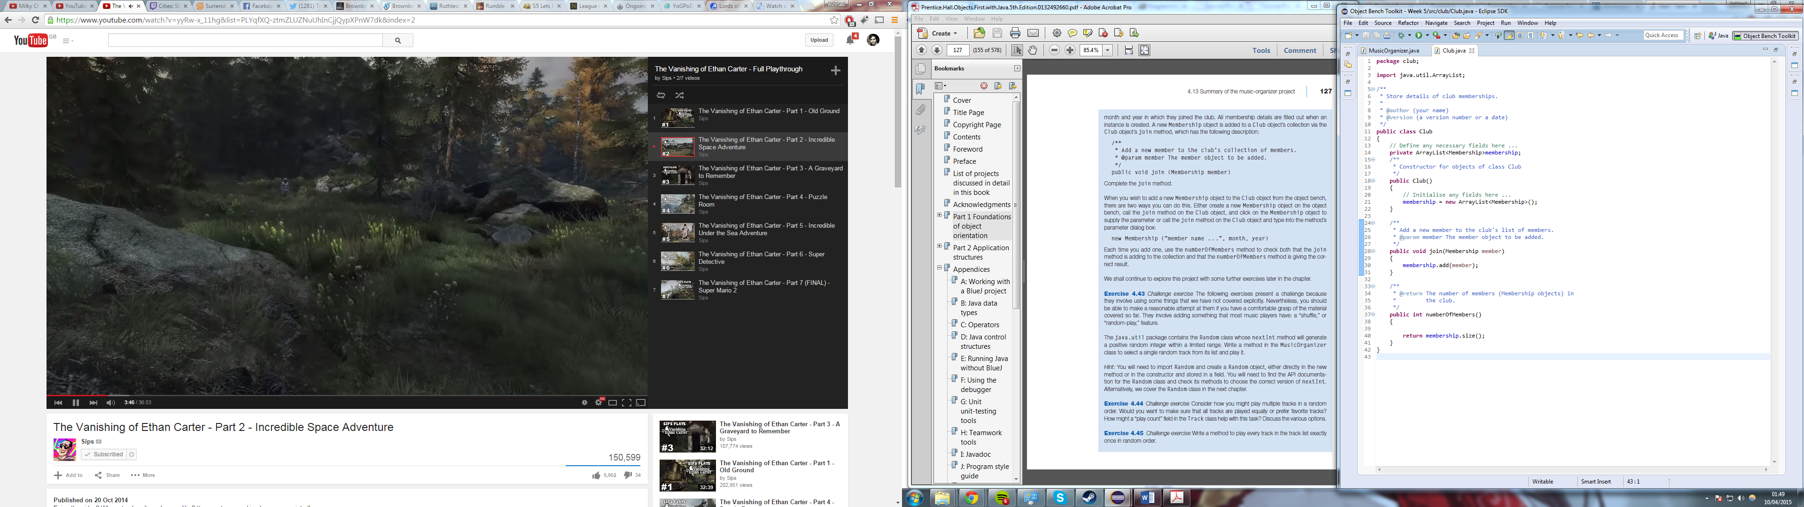

Figure 109 – Code editor view for Club Class, adding a join method.

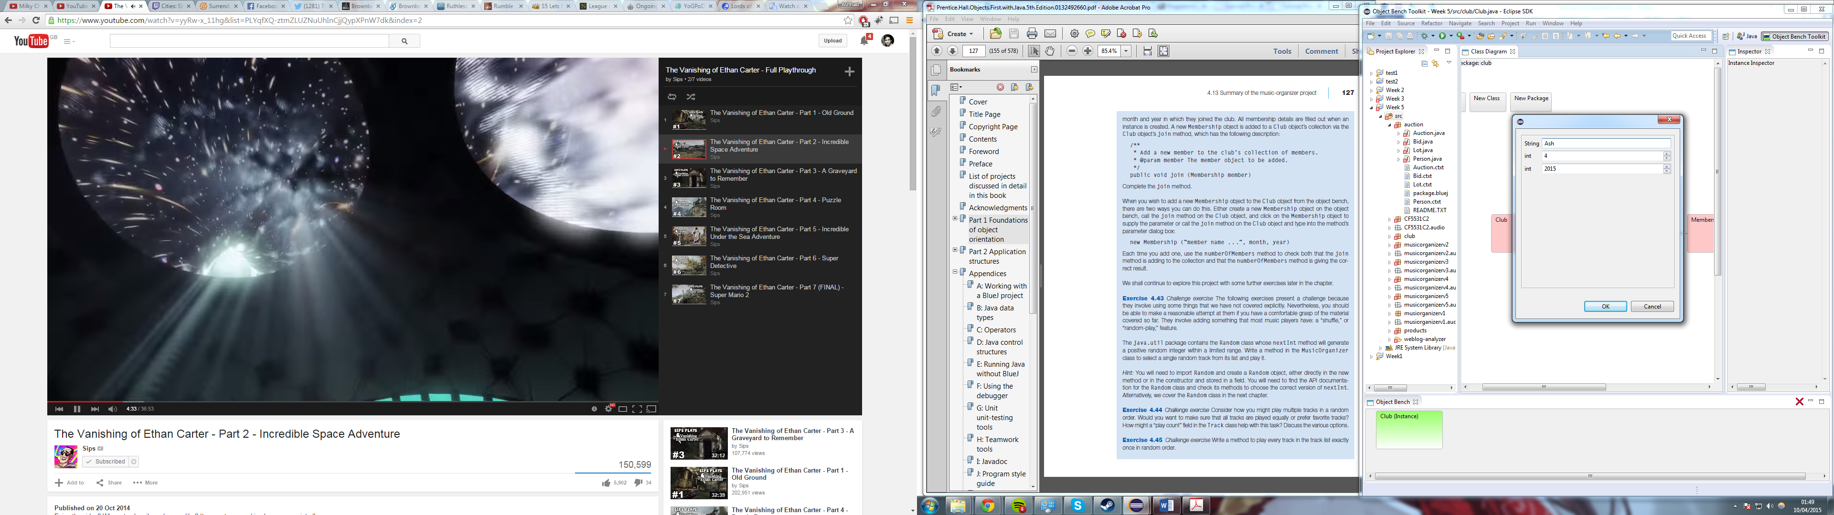

Figure 110 – Prompt for instantiating a membership.

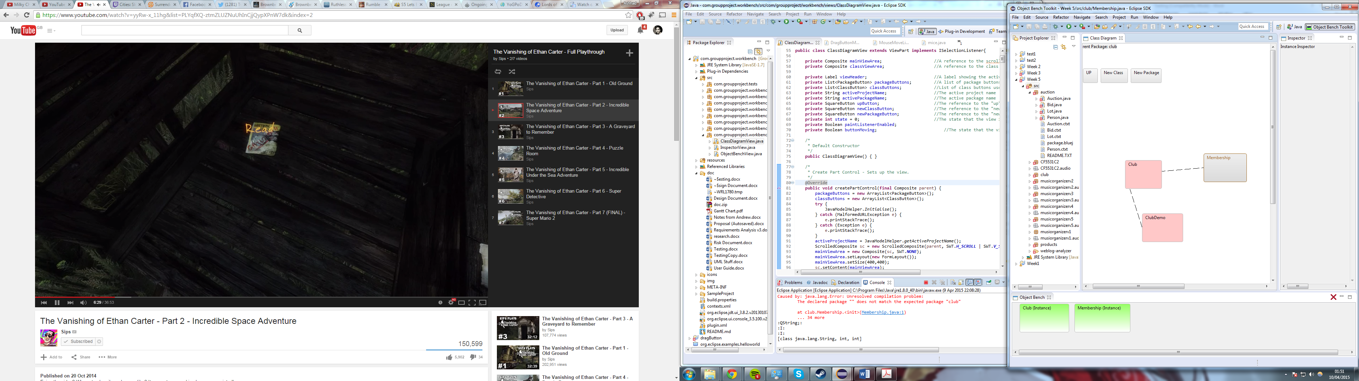

Figure 111 – Membership class instantiated on the object bench.

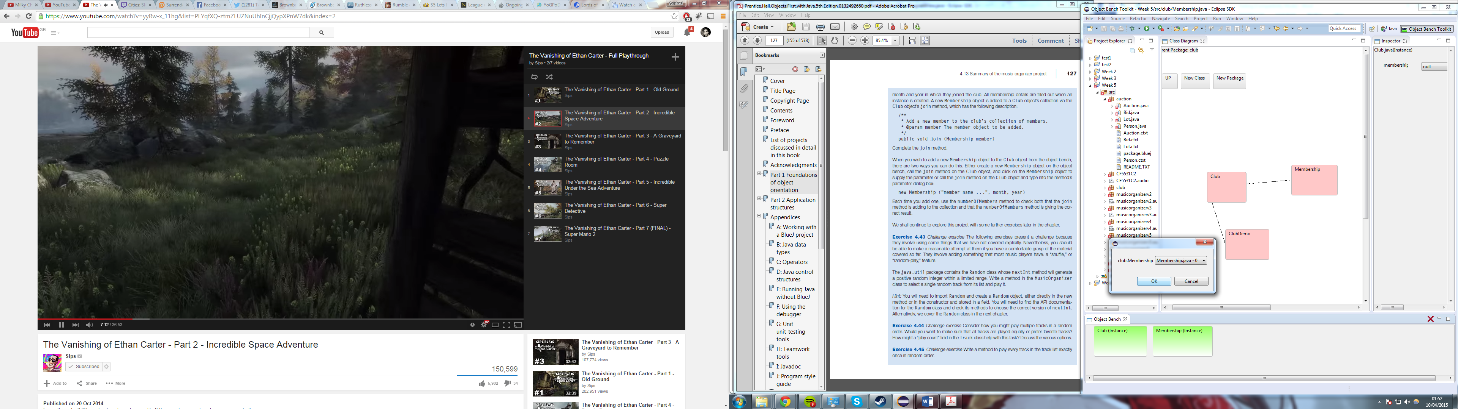

Figure 112 – Prompt for choosing a member when calling the join method.

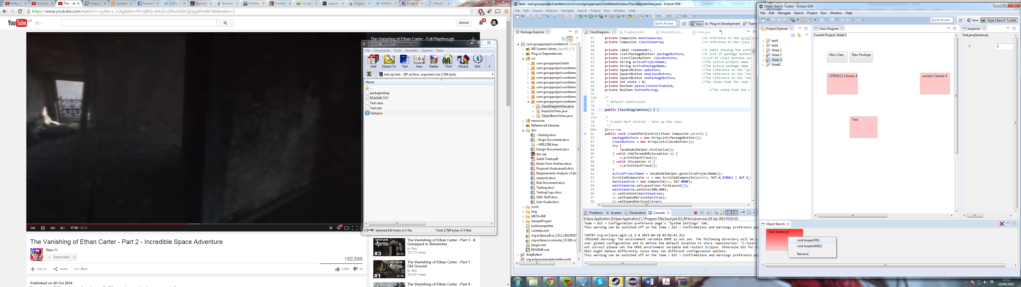

Figure 113 – The available methods for Test class.

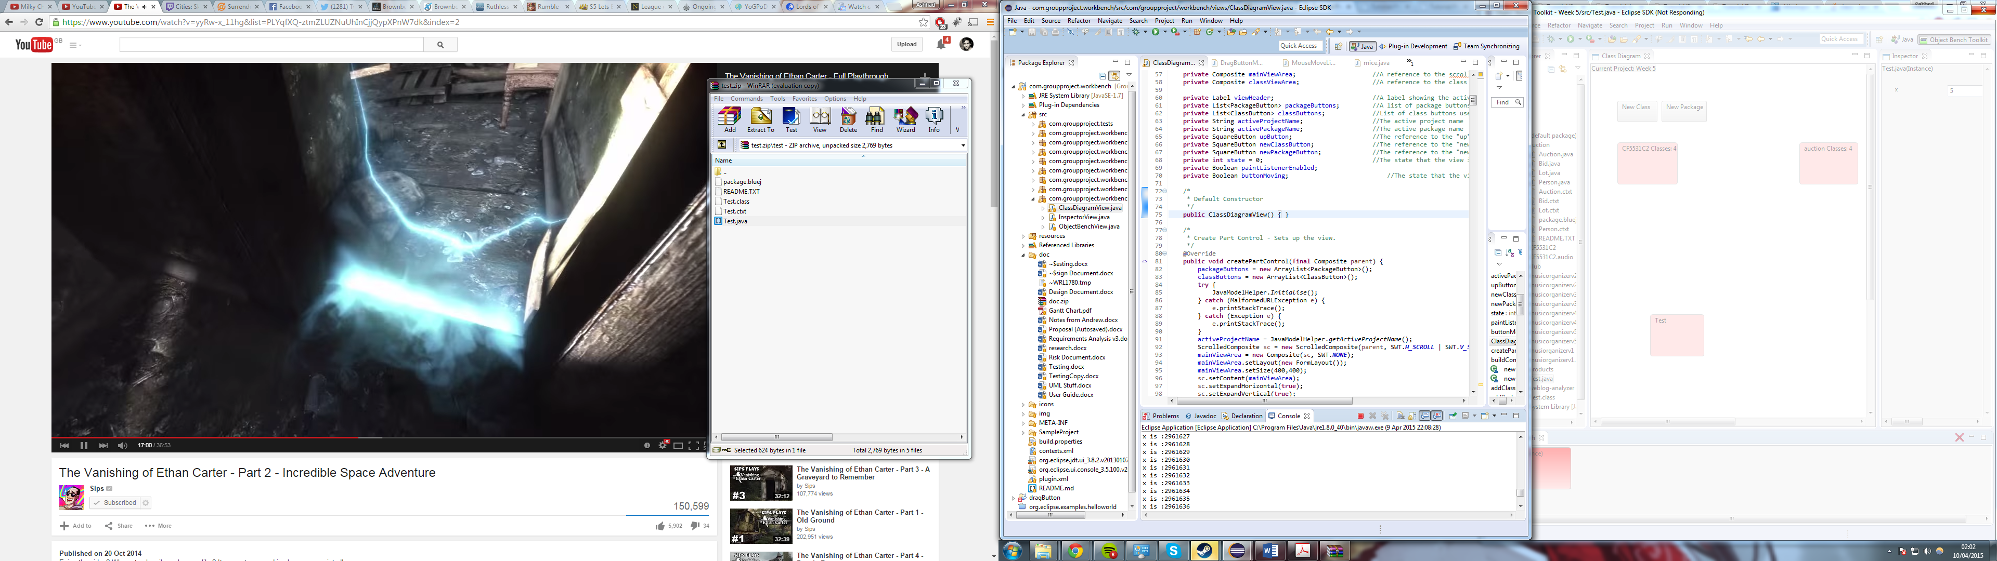

Figure 114 – Output for calling looperOR method

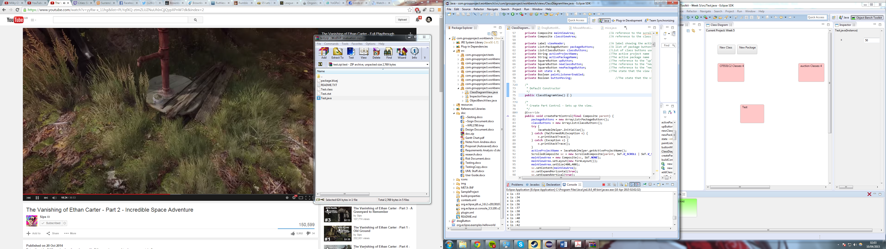

Figure 115 – Output for calling looperAND method.

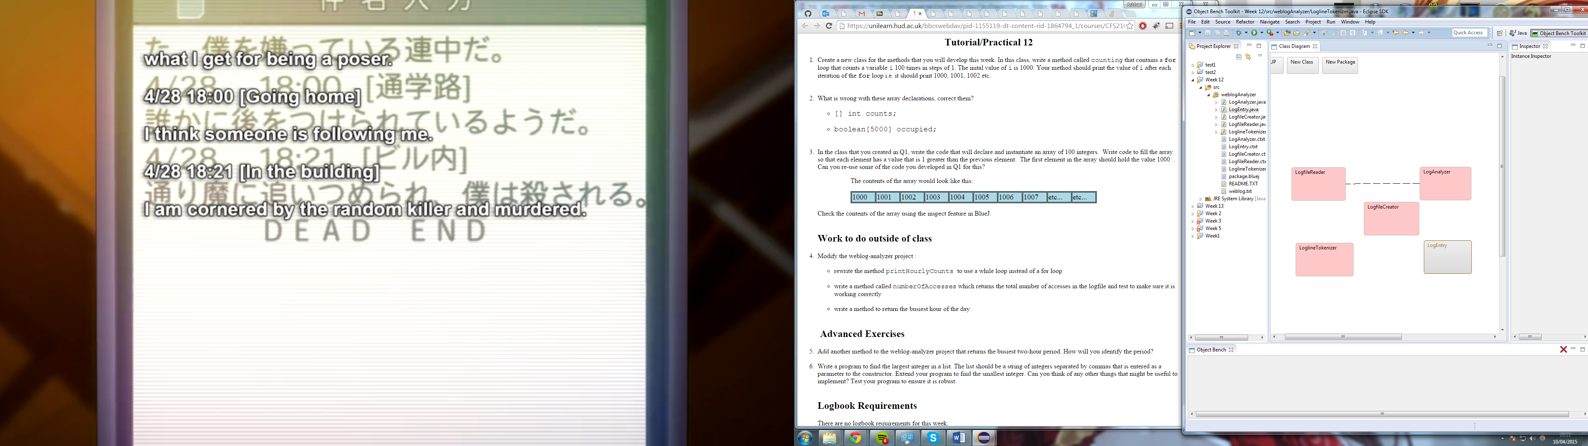

Figure 116 – Class Diagram for weblog analyser project.

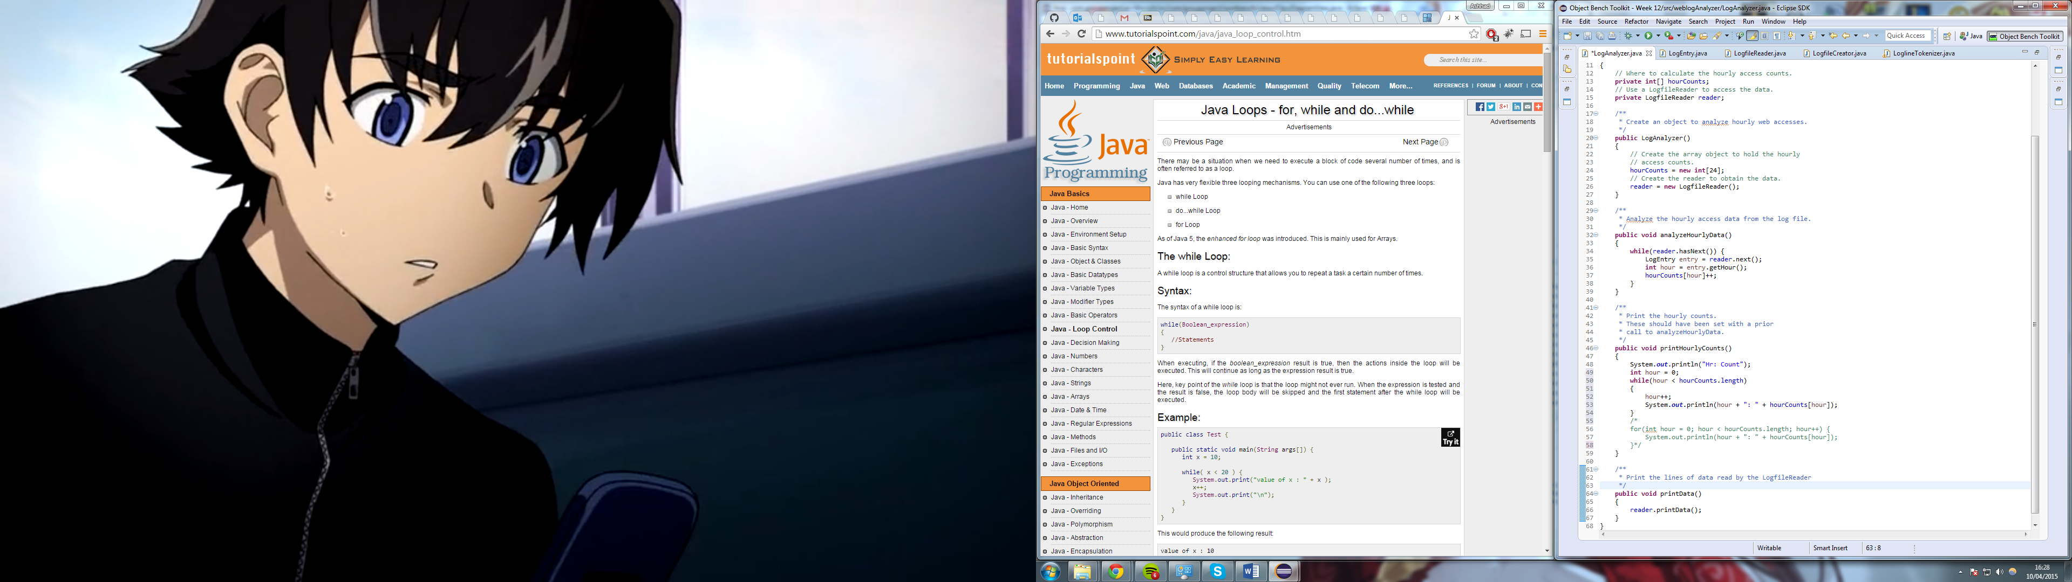

Figure 117 – Code editor view with the new while loop.

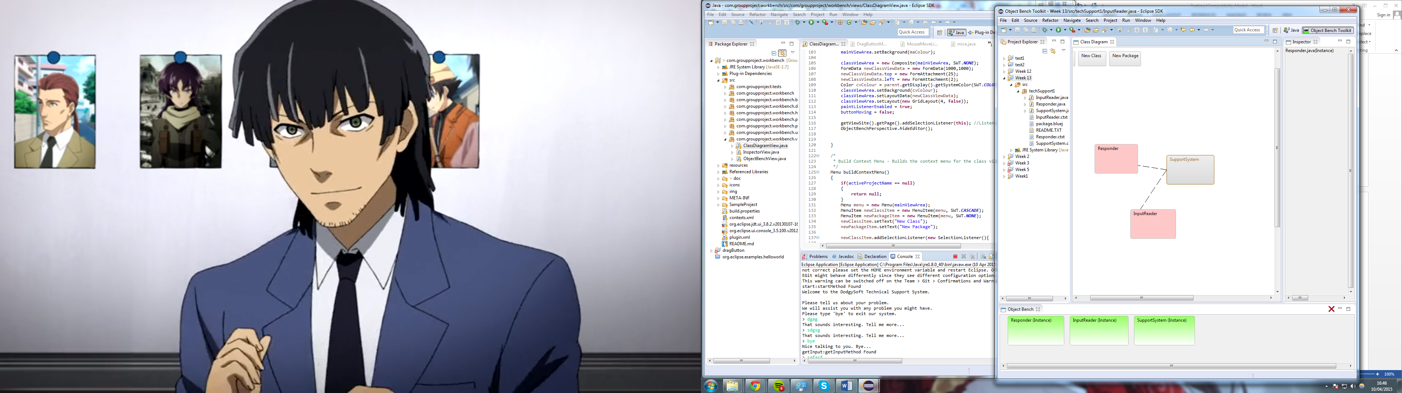

Figure 118 – Class diagram, instantiated classes and output of start method.

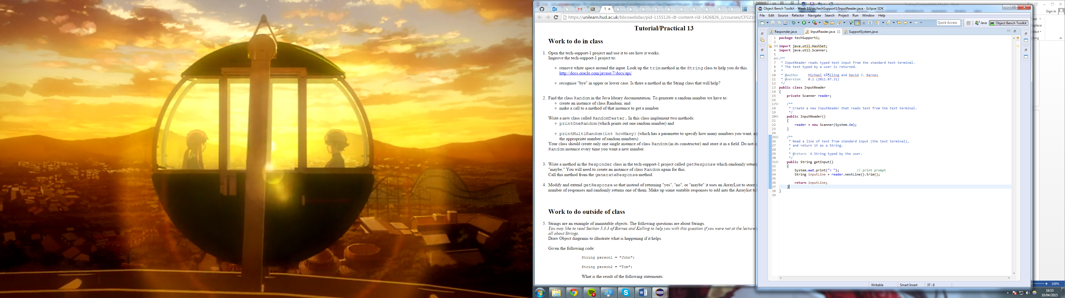

Figure 119 – Code editor view with the added .trim() method

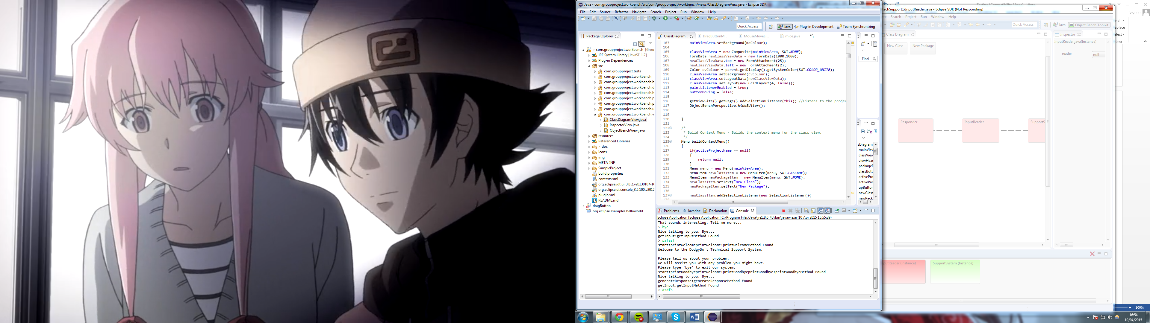

Figure 120 – Input of words with lot of white space at the end (sadly the white space is not visible but it is there).

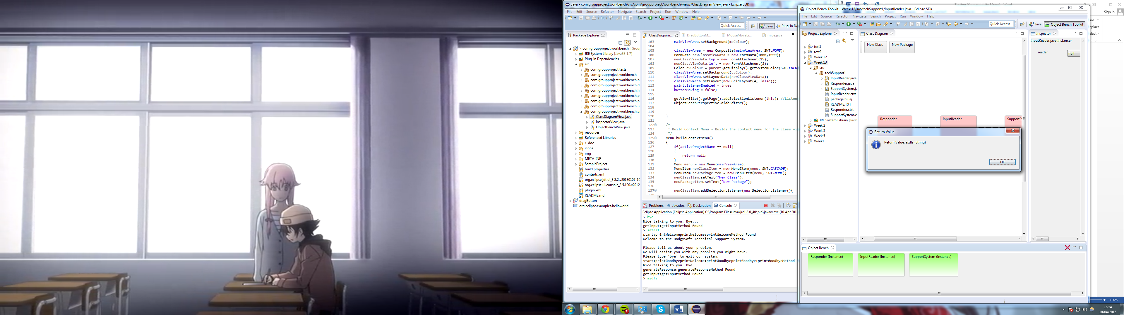

Figure 121 – Output of inputReaders getInput method, no whitespaces due to added .trim().

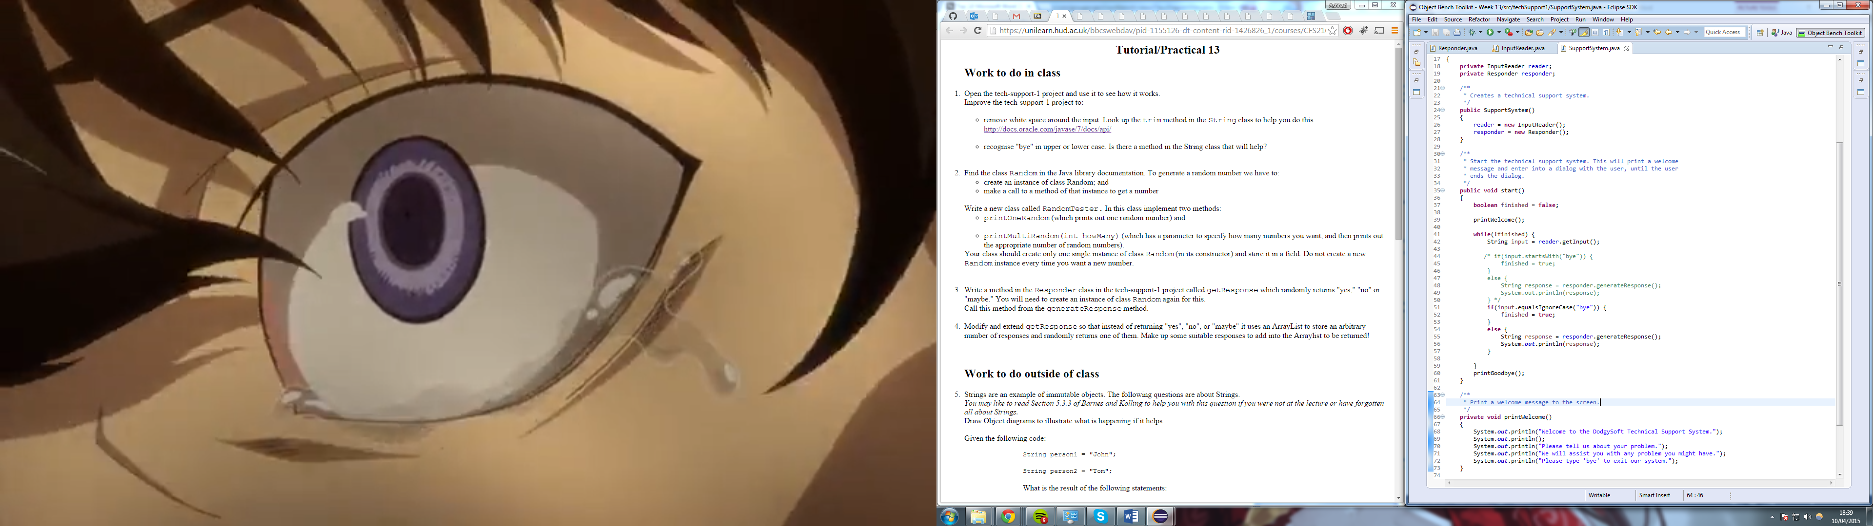

Figure 122 – Code editor view with the adjusted equalsIgnoreCase method.

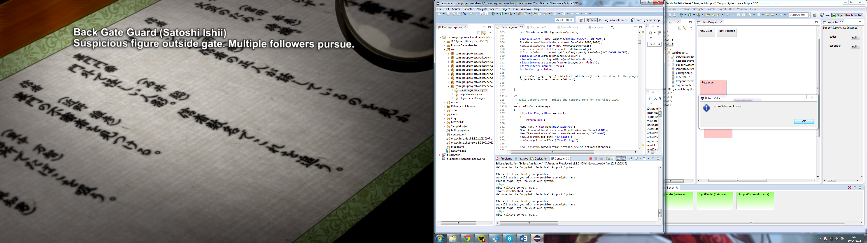

Figure 123 – Output showing new equalsIgnoreCase working